Software Requirements Specification

For

Breezy Airlines

Prepared by

|  |
| --- |
| John Rollins |
| Jasmine McCants |
| Vishal Patel |
| Madison Haake |
| John Rollins |
|  |

|  |  |
| --- | --- |
| Instructor: | Dr. Schwartz |
| Course: | Software Engineering |
| Date: | December 3, 2018 |

|  |  |
| --- | --- |
|  |  |

Contents

1 Introduction 1

1.1 Product Purpose 1

2 Overall Description 1

2.2 Product Functionality 1

3 Specific Requirements 2

3.1 User Interfaces and Functional Requirements 2

# Introduction

## Product Purpose

The purpose of our software, Breezy Airlines, is to provide a website for a small airline that has one-way tickets to a few locations. The website is very easy to navigate for the customer. There is a sidebar proving the user with easy access to the main pages, and each page includes a button to point the user in the direction of the next page.

The user will go through the basic steps to eventually book their flight including create a user, look for the flight they want to book, and book the flight. The user will also have easy access to their flights and tickets. The goal of this software is to give the user an easy-to-use website to book their flights to major cities around the area.

# Overall Description

## Product Functionality

Basic User will be able to:

* The users will be able to register an account and login.
* Search for flights by date and destination.
* Select a desired flight from a list that is returned from their search.
* Enter the personal information of all additional passengers.
* Select their seat(s) from the seats available on the flight.
* Pay for their flight tickets.
* View all of the flights and flight statuses.
* View all of their tickets.

User:

* The user will enter their email and password to login to their personal account.
* The user will be able to view/print their tickets.
* The user will be able to check flight status.
* The user will be able to cancel their flight.

Administrator:

* The administrator will login using their “secret password” given to them by the airline company.
* The administrator will have the ability to do everything the user can do.
* The administrator will be able to add a flight.
* The administrator will be able to update a flight status
* The administrator will be able to check the flight manifest.

# Specific Requirements

## User Interfaces and Functional Requirements

### Use Case View

### User Interfaces

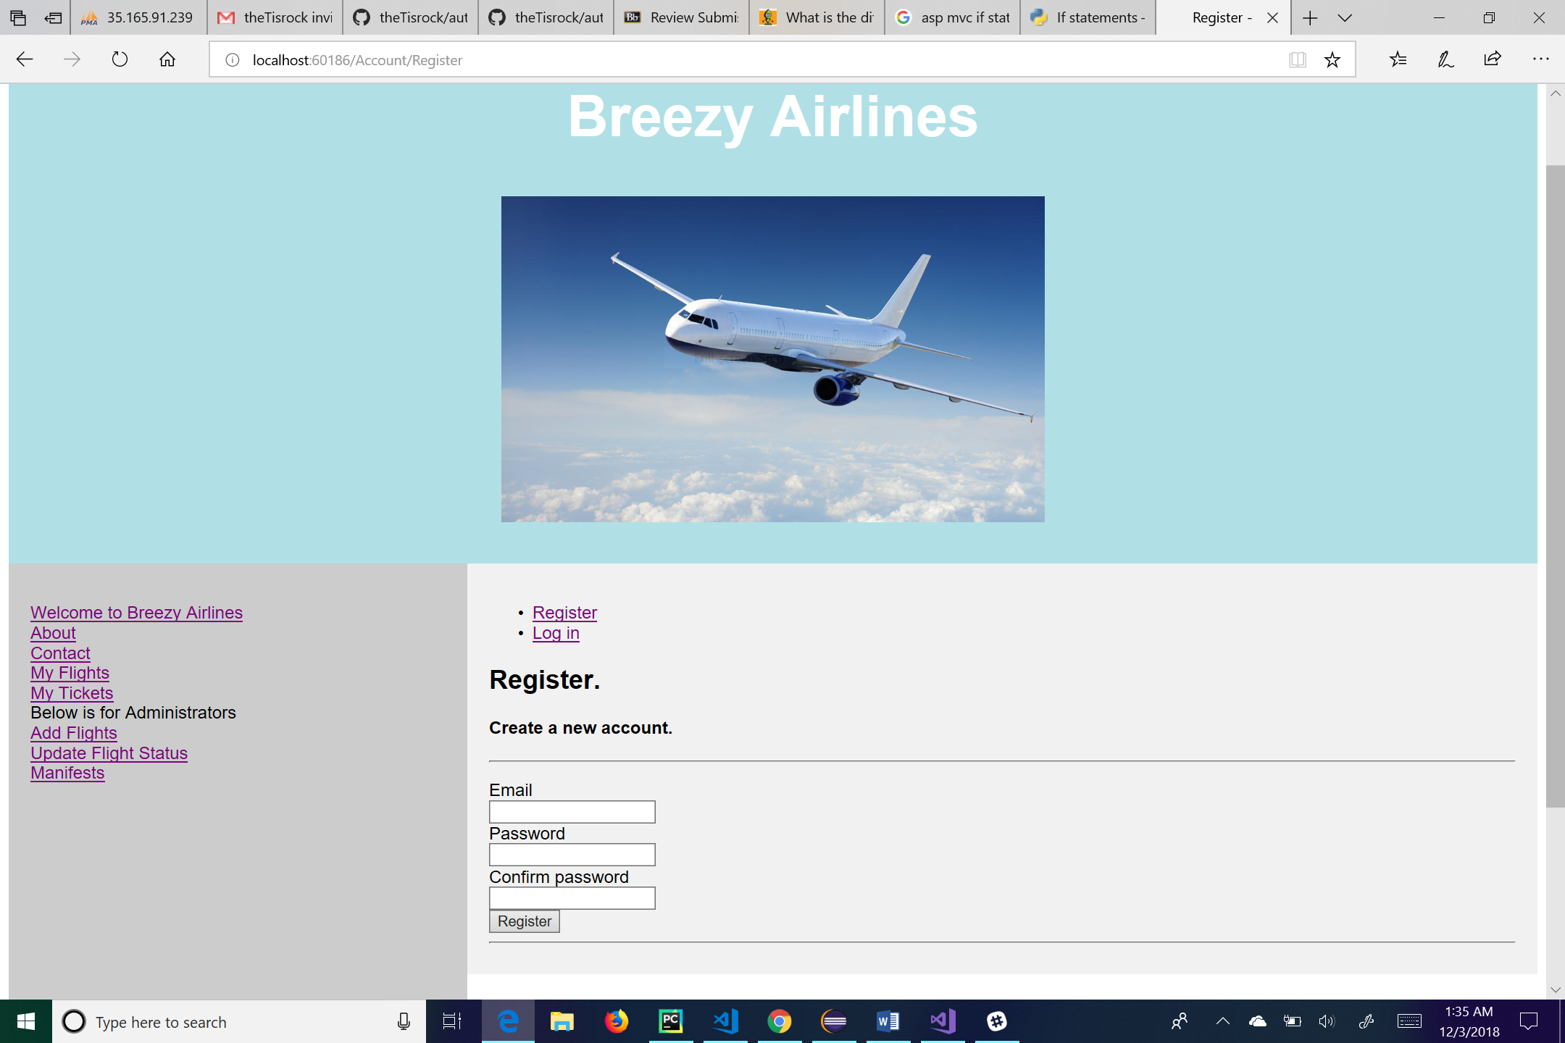

This is the user Log-in page. If the user is already registered, they will use their unique email/username and password to log into their account. Once the correct email and password are entered the user will click the Log in button and be taken to the main page. Clicking the “Remember Me” box will allow the computer to remember your password along with your email when you go to log-in again. If you are not already registered, you will click on either the “Register as a new user” link or the “Register” link and will then be taken to the Registration page.

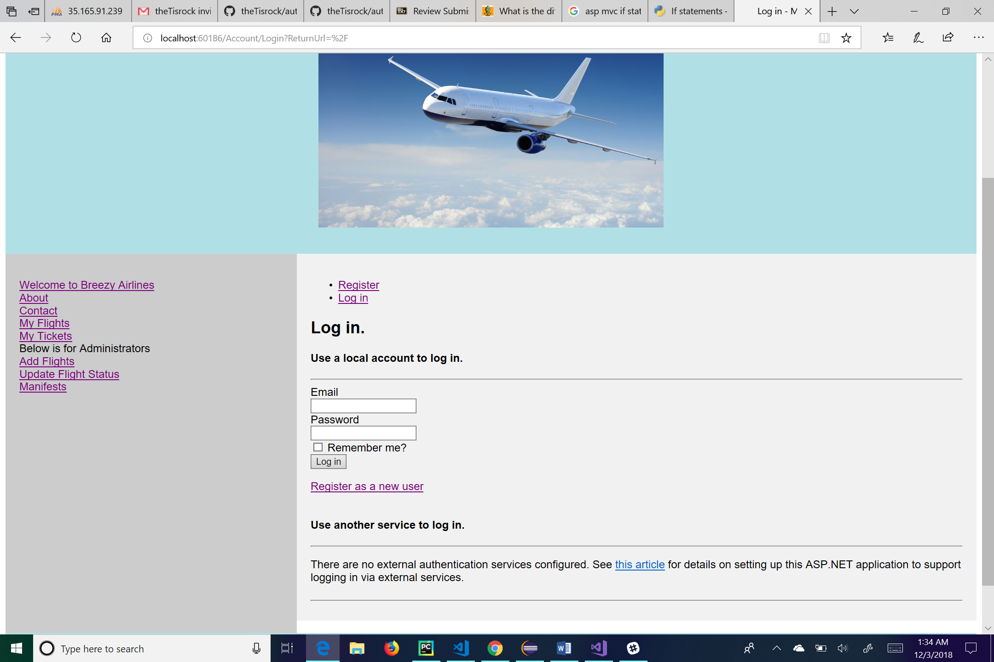

This is the Registration page. If the user is not already registered they will be taken to this page to make an account. Here they will choose an email to enter into the email textbox, and then the user will enter in a password of their choice first into the password textbox and then again into the confirm password textbox. Once they are comfortable with their decision for both email and password, they will click the Register button. If their password is not to certain specifications, the registration will fail, and the user will be asked to enter a new password with those specifications. When the registration succeeds, the user will be taken to the Main Page.

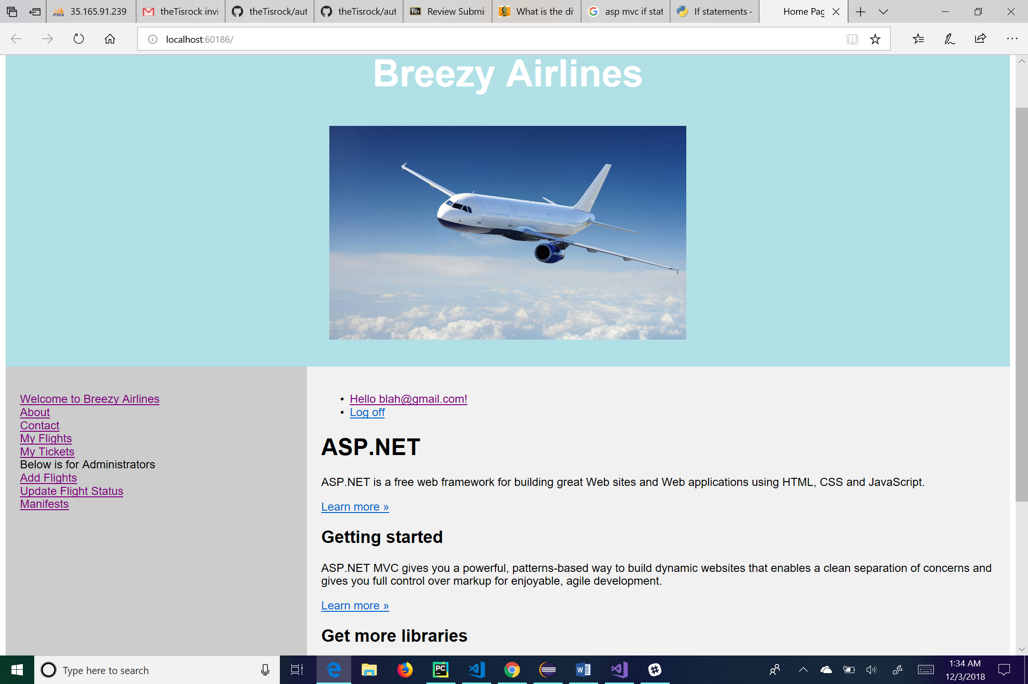

This is the first page the user will be taken to after either logging in or registering. From here the user can log off by clicking the “Log off” link, manage their account by clicking on the link of their email, go to the main page by clicking the “Welcome to Breezy Airlines” link, go to his or her flights by clicking the “My Flights” link, go to his or her tickets by clicking the “My Tickets” link, go to the about page by clicking the “About” link, or go to the contact page by clicking the “Contact” link. For administrative use, the user can click on the “Add Flights” link to add a flight to the database, click on the “Update Flight Status” link to change a flight status, or click on the “Manifests” link to see a manifest of the flight.

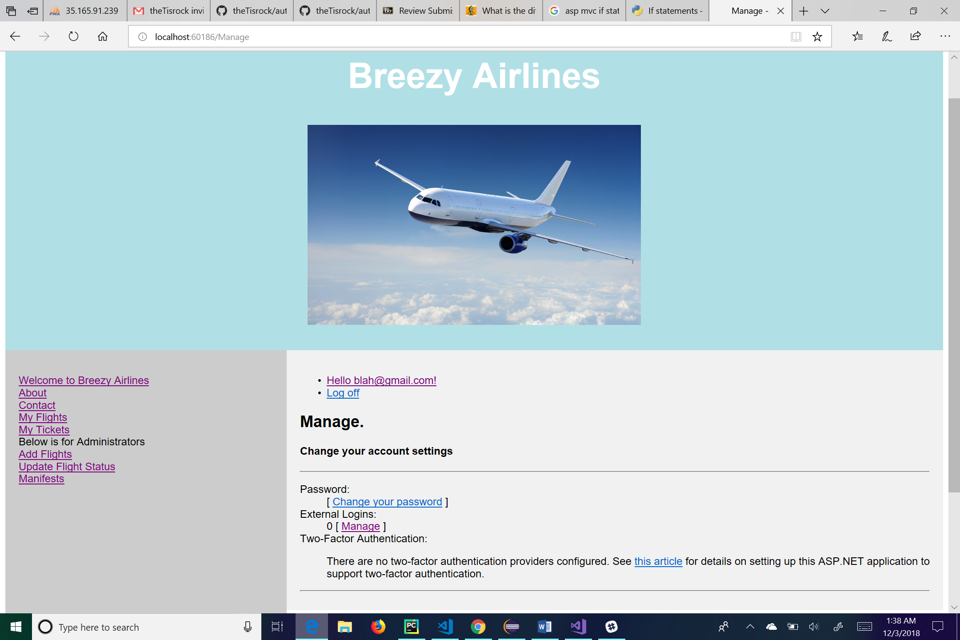

This is the page used to manage your account. The user can change his or her password by clicking on the “Change your password” link. The “Manage” link will take the user to a page stating that there are no external logins. From here the user can log off by clicking the “Log off” link, manage their account by clicking on the link of their email, go to the main page by clicking the “Welcome to Breezy Airlines” link, go to his or her flights by clicking the “My Flights” link, go to his or her tickets by clicking the “My Tickets” link, go to the about page by clicking the “About” link, or go to the contact page by clicking the “Contact” link. For administrative use, the user can click on the “Add Flights” link to add a flight to the database, click on the “Update Flight Status” link to change a flight status, or click on the “Manifests” link to see a manifest of the flight.

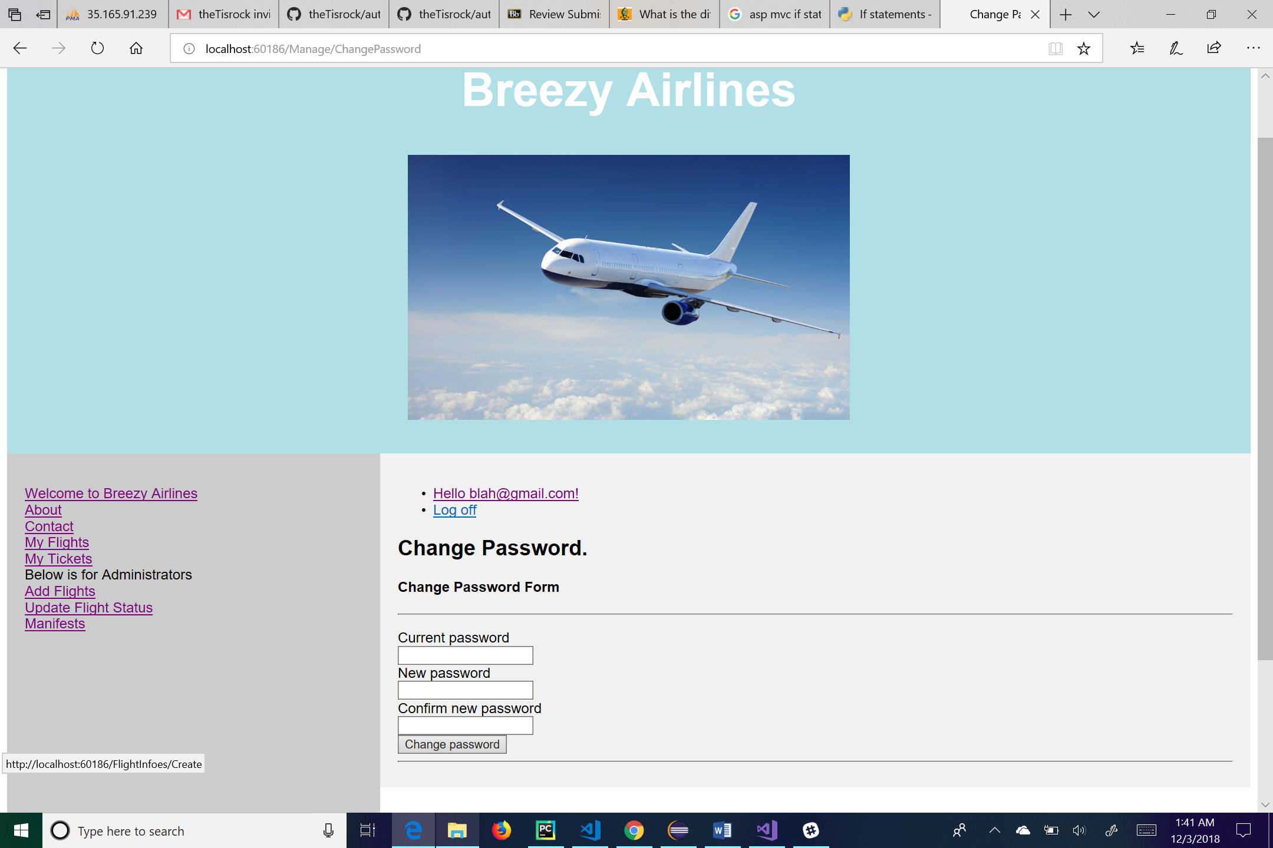

This is the change password page. Here the user will fill in the appropriate textboxes with his or her current and new passwords. Clicking on the “Change password” button with change the user’s password and take the user back to the manage page. From here the user can log off by clicking the “Log off” link, manage their account by clicking on the link of their email, go to the main page by clicking the “Welcome to Breezy Airlines” link, go to his or her flights by clicking the “My Flights” link, go to his or her tickets by clicking the “My Tickets” link, go to the about page by clicking the “About” link, or go to the contact page by clicking the “Contact” link. For administrative use, the user can click on the “Add Flights” link to add a flight to the database, click on the “Update Flight Status” link to change a flight status, or click on the “Manifests” link to see a manifest of the flight.

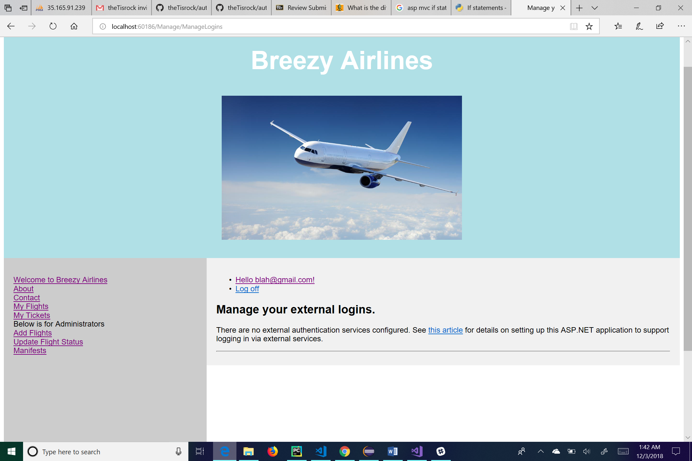

The user can get to this page by clicking on the “Manage” link under External Logins on the previous page. This page just lets the user know that there are no external logins for this particular application. From here the user can log off by clicking the “Log off” link, manage their account by clicking on the link of their email, go to the main page by clicking the “Welcome to Breezy Airlines” link, go to his or her flights by clicking the “My Flights” link, go to his or her tickets by clicking the “My Tickets” link, go to the about page by clicking the “About” link, or go to the contact page by clicking the “Contact” link. For administrative use, the user can click on the “Add Flights” link to add a flight to the database, click on the “Update Flight Status” link to change a flight status, or click on the “Manifests” link to see a manifest of the flight.

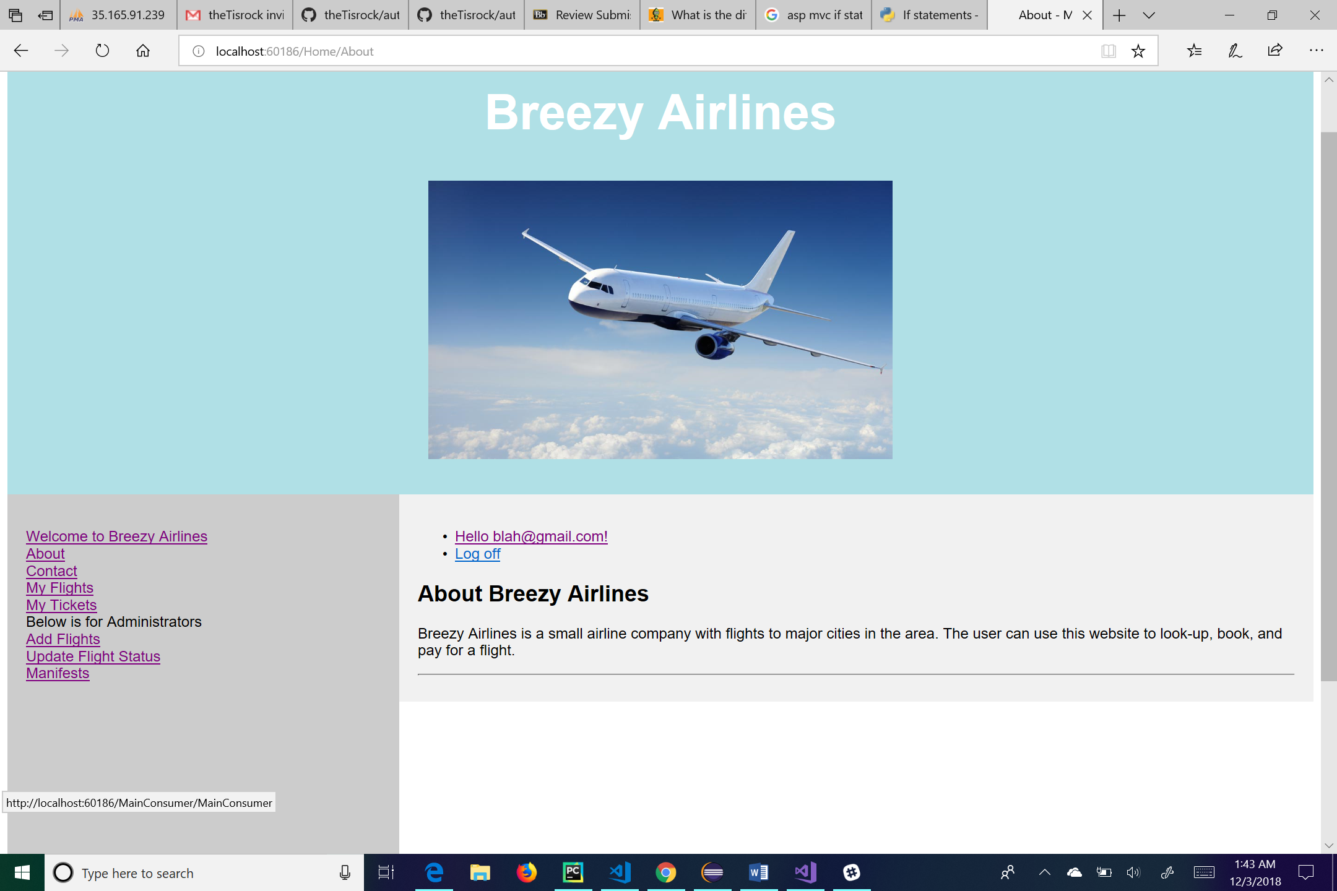

This is the about page for Breezy Airlines. Here there is a short description of what Breezy Airlines is about. From here the user can log off by clicking the “Log off” link, manage their account by clicking on the link of their email, go to the main page by clicking the “Welcome to Breezy Airlines” link, go to his or her flights by clicking the “My Flights” link, go to his or her tickets by clicking the “My Tickets” link, go to the about page by clicking the “About” link, or go to the contact page by clicking the “Contact” link. For administrative use, the user can click on the “Add Flights” link to add a flight to the database, click on the “Update Flight Status” link to change a flight status, or click on the “Manifests” link to see a manifest of the flight.

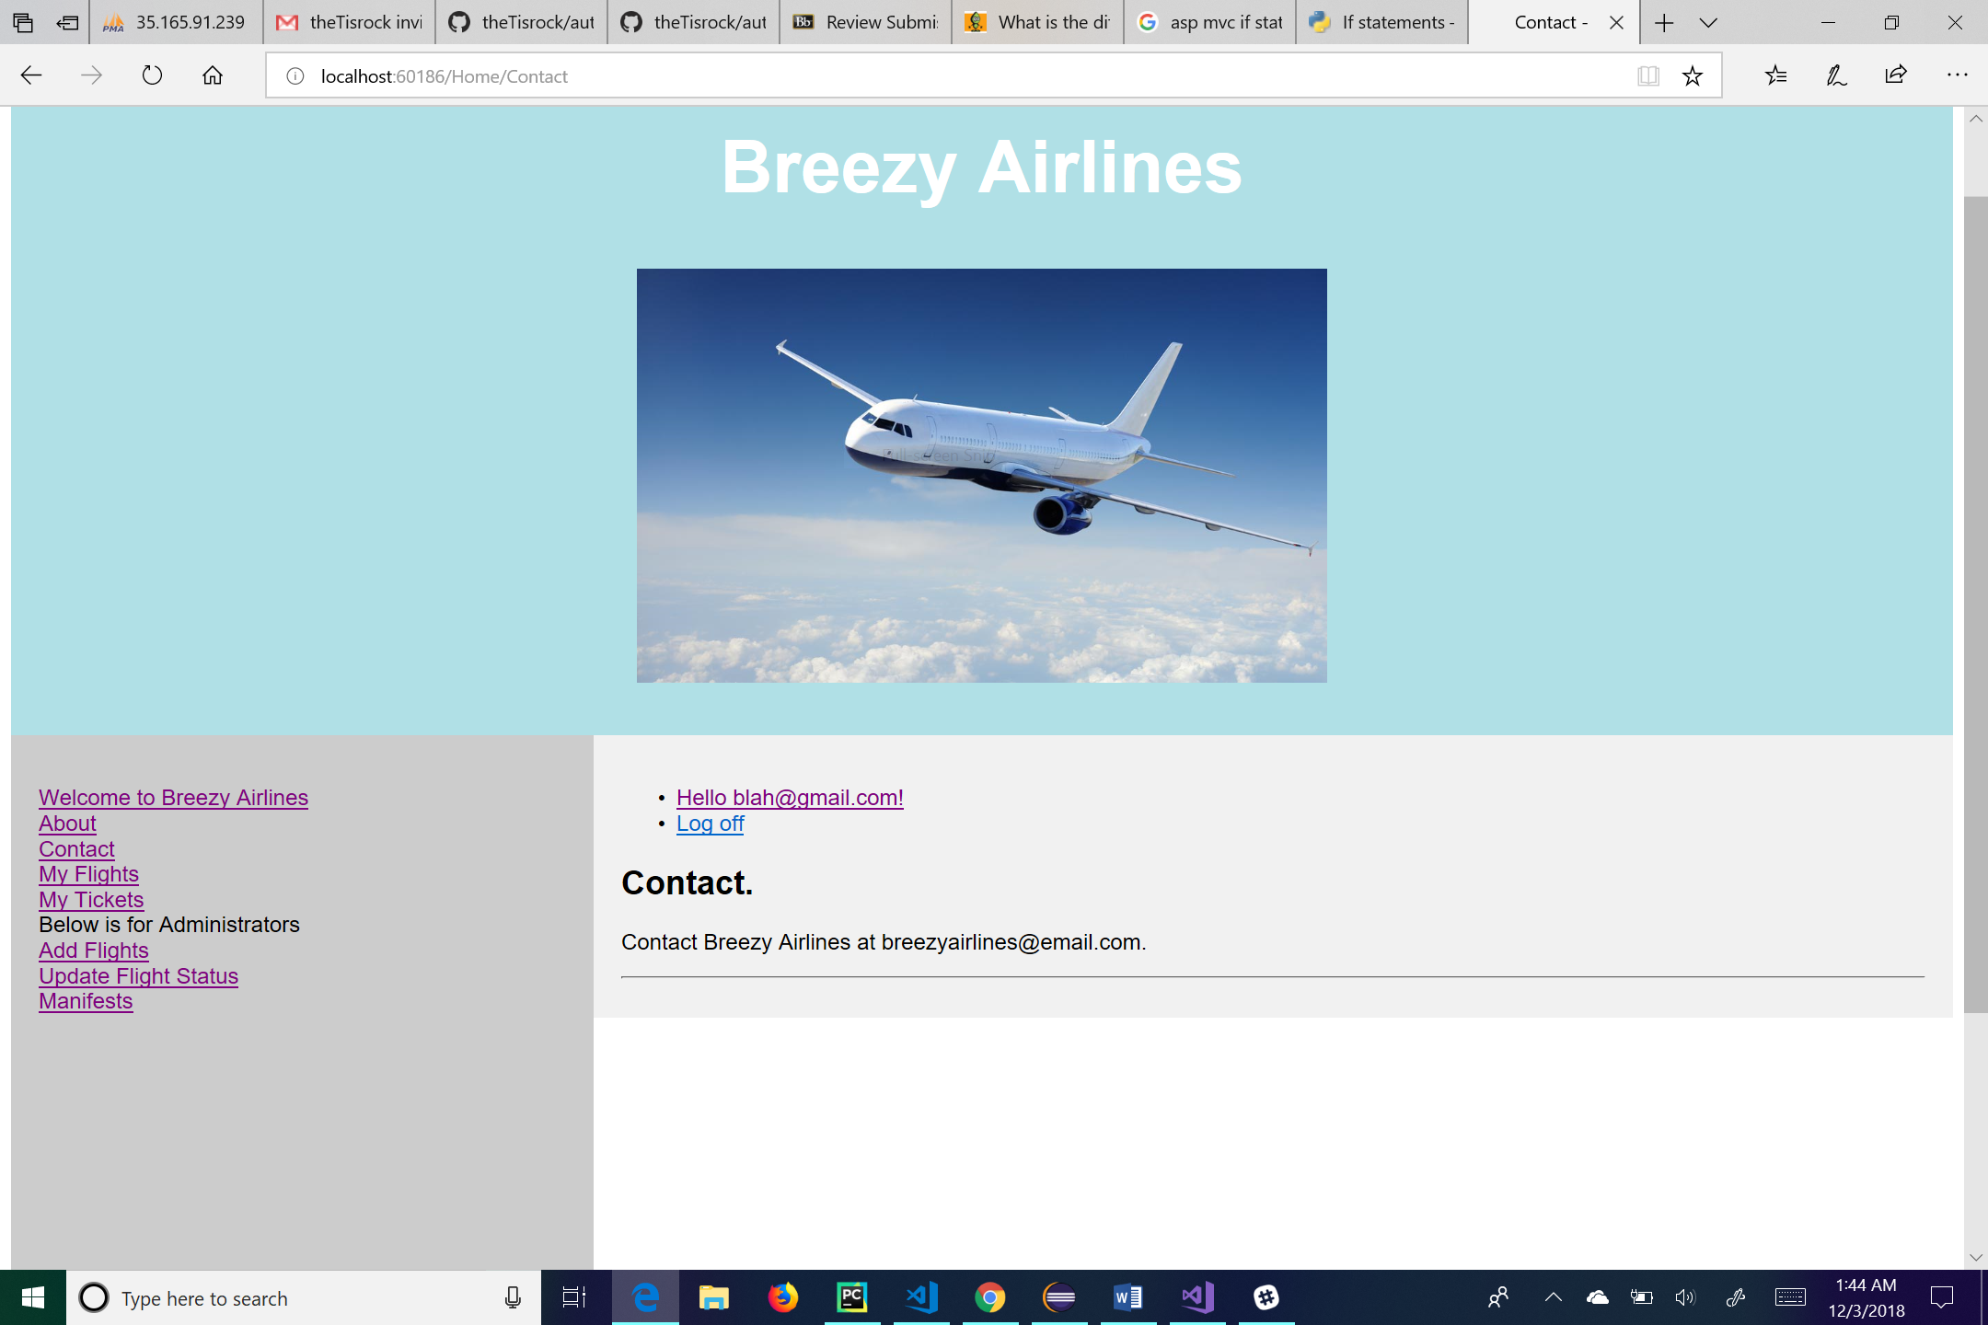

This is the contact page for Breezy Airlines. It provides the contact information for the company. From here the user can log off by clicking the “Log off” link, manage their account by clicking on the link of their email, go to the main page by clicking the “Welcome to Breezy Airlines” link, go to his or her flights by clicking the “My Flights” link, go to his or her tickets by clicking the “My Tickets” link, go to the about page by clicking the “About” link, or go to the contact page by clicking the “Contact” link. For administrative use, the user can click on the “Add Flights” link to add a flight to the database, click on the “Update Flight Status” link to change a flight status, or click on the “Manifests” link to see a manifest of the flight.

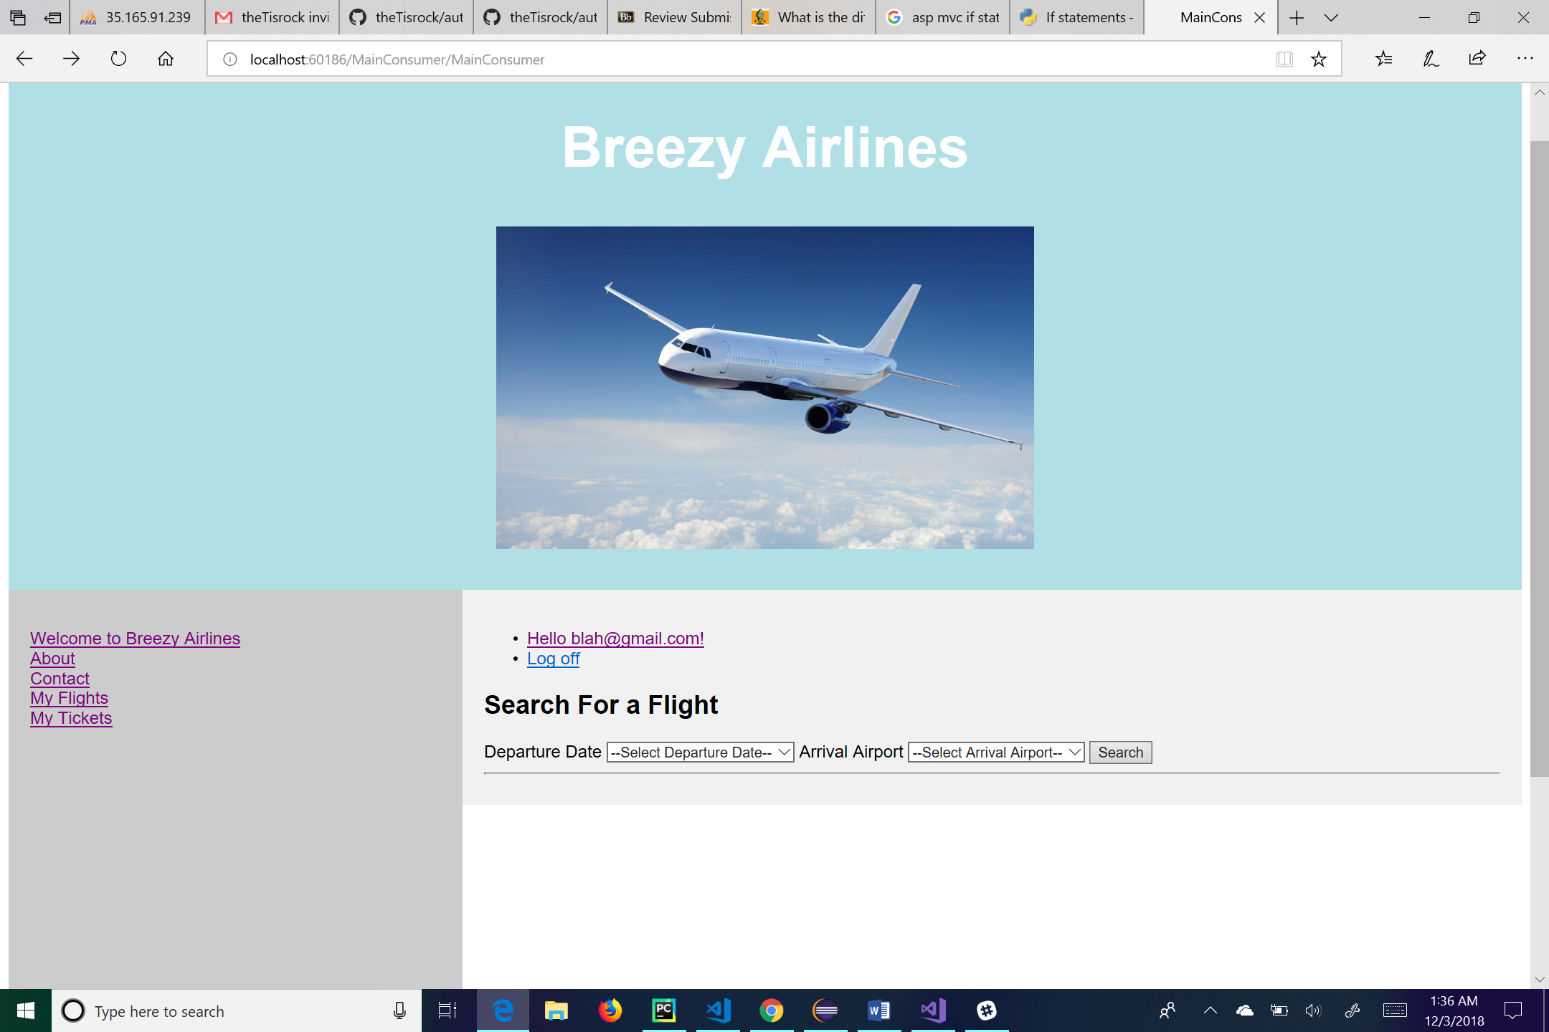

This is the main page, and it comes from clicking on the “Welcome to Breezy Airlines” link. From here the user can log off by clicking the “Log off” link, manage their account by clicking on the link of their email, go to the main page by clicking the “Welcome to Breezy Airlines” link, go to his or her flights by clicking the “My Flights” link, go to his or her tickets by clicking the “My Tickets” link, go to the about page by clicking the “About” link, or go to the contact page by clicking the “Contact” link. For administrative use, the user can click on the “Add Flights” link to add a flight to the database, click on the “Update Flight Status” link to change a flight status, or click on the “Manifests” link to see a manifest of the flight. When searching for a flight, the user will click the dropdown list next to Departure Date and select from the available dates. Then the user will click the dropdown list next to Arrival Airport and select from the available airports. Selecting the “Search” button will take the user to the Flight Selection page.

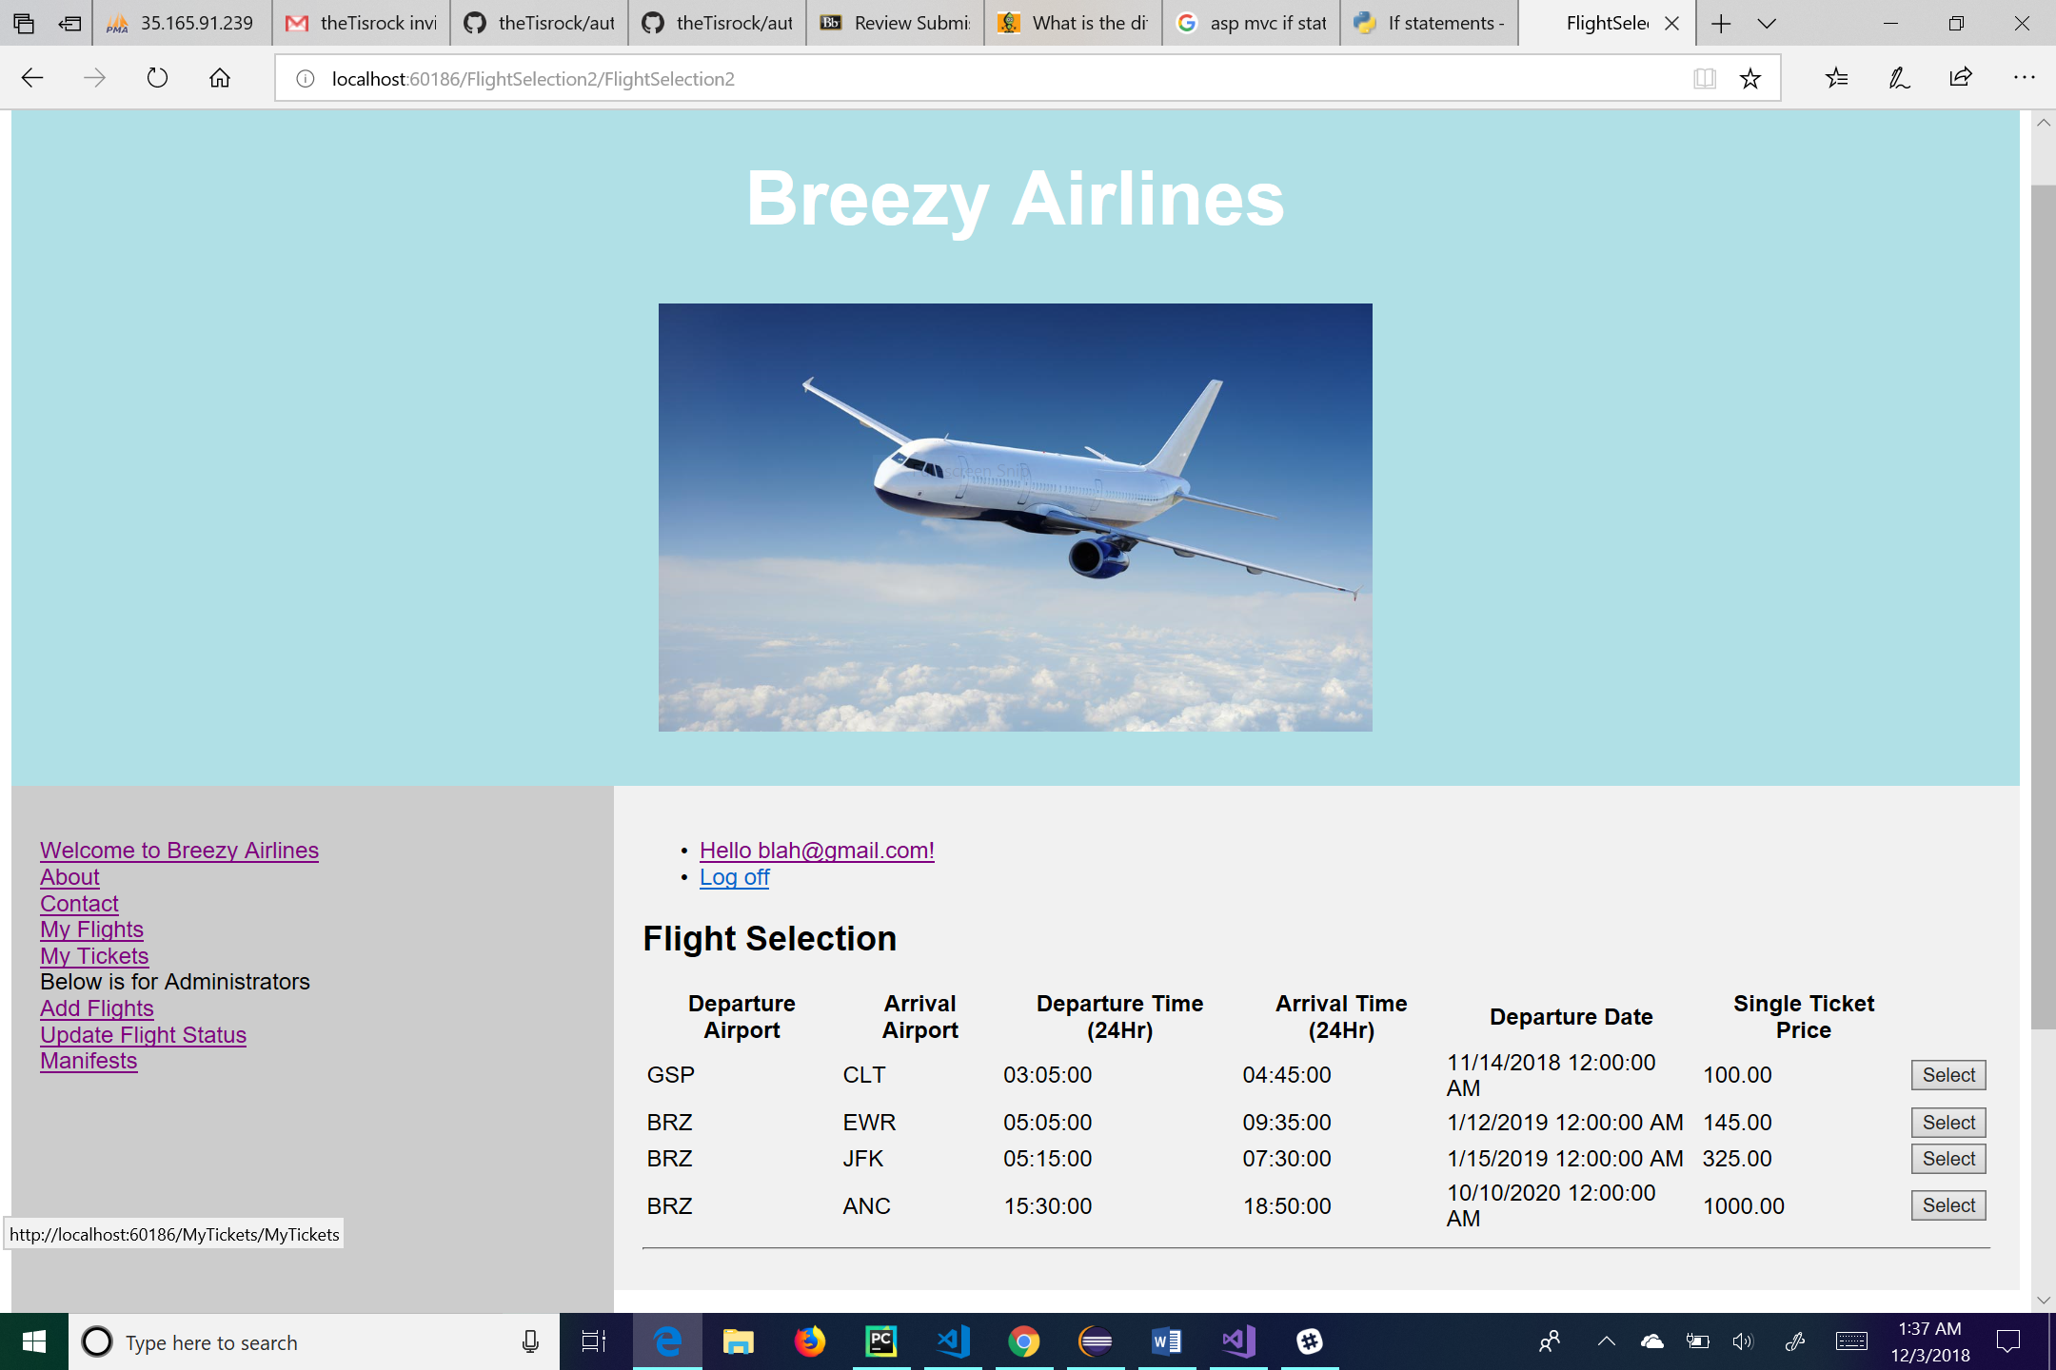

This is the flight selection page. From here the user can log off by clicking the “Log off” link, manage their account by clicking on the link of their email, go to the main page by clicking the “Welcome to Breezy Airlines” link, go to his or her flights by clicking the “My Flights” link, go to his or her tickets by clicking the “My Tickets” link, go to the about page by clicking the “About” link, or go to the contact page by clicking the “Contact” link. For administrative use, the user can click on the “Add Flights” link to add a flight to the database, click on the “Update Flight Status” link to change a flight status, or click on the “Manifests” link to see a manifest of the flight. On this page, the user will be able to select a flight that they wish to book by clicking the “Select” button next to the flight. When they select a flight, they will be brought to the passenger information page.

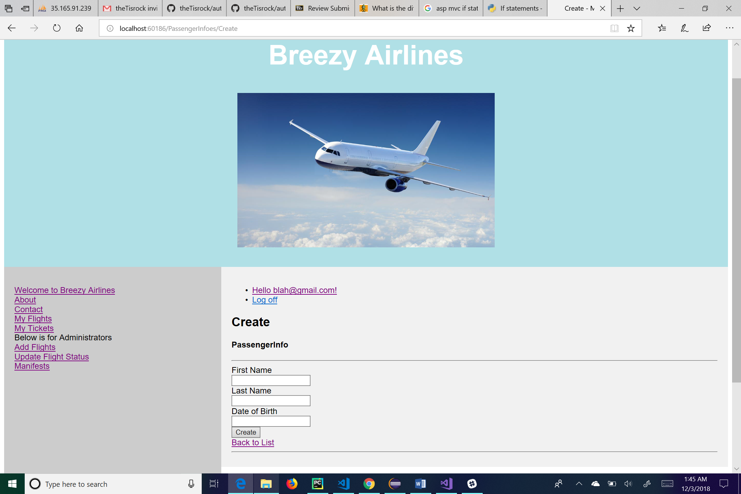

This is the create page for passenger information. From here the user can log off by clicking the “Log off” link, manage their account by clicking on the link of their email, go to the main page by clicking the “Welcome to Breezy Airlines” link, go to his or her flights by clicking the “My Flights” link, go to his or her tickets by clicking the “My Tickets” link, go to the about page by clicking the “About” link, or go to the contact page by clicking the “Contact” link. For administrative use, the user can click on the “Add Flights” link to add a flight to the database, click on the “Update Flight Status” link to change a flight status, or click on the “Manifests” link to see a manifest of the flight. On this page the user will create a passenger by entering their first and last names into the appropriate textboxes and entering their date of birth into the textbox labeled “Date of Birth”. Once you have filled all the text fields, the user can click create and be taken to the passenger information page. The user also has the ability to go back to the list of flights by clicking the link labeled “Back to List”.ppropoxes and entering their date of birth into thd last names into the appropiate application. elect from the available dates.

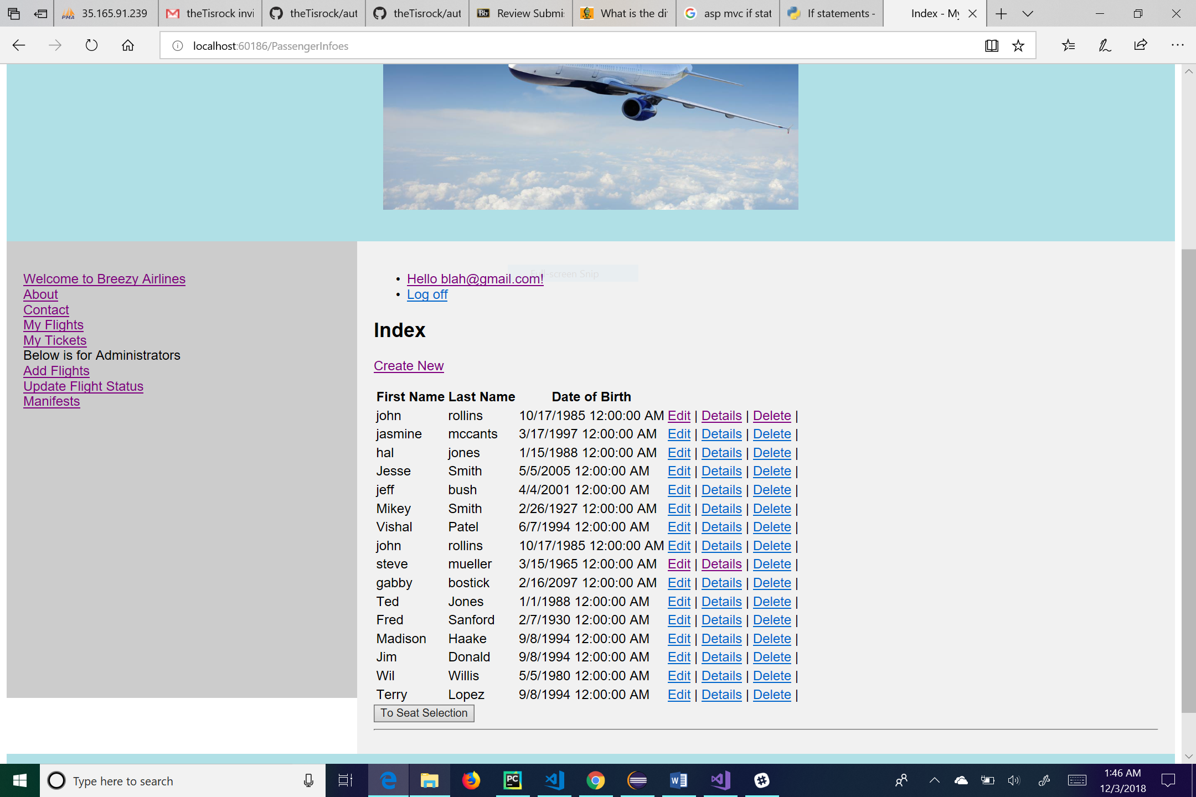

This is the passenger information page. This page is used to see any passengers registered to the flight. From here the user can log off by clicking the “Log off” link, manage their account by clicking on the link of their email, go to the main page by clicking the “Welcome to Breezy Airlines” link, go to his or her flights by clicking the “My Flights” link, go to his or her tickets by clicking the “My Tickets” link, go to the about page by clicking the “About” link, or go to the contact page by clicking the “Contact” link. For administrative use, the user can click on the “Add Flights” link to add a flight to the database, click on the “Update Flight Status” link to change a flight status, or click on the “Manifests” link to see a manifest of the flight. The “Seat Selection” button at the bottom of the page takes the user to a page where he or she can select the seat of his or her choice.

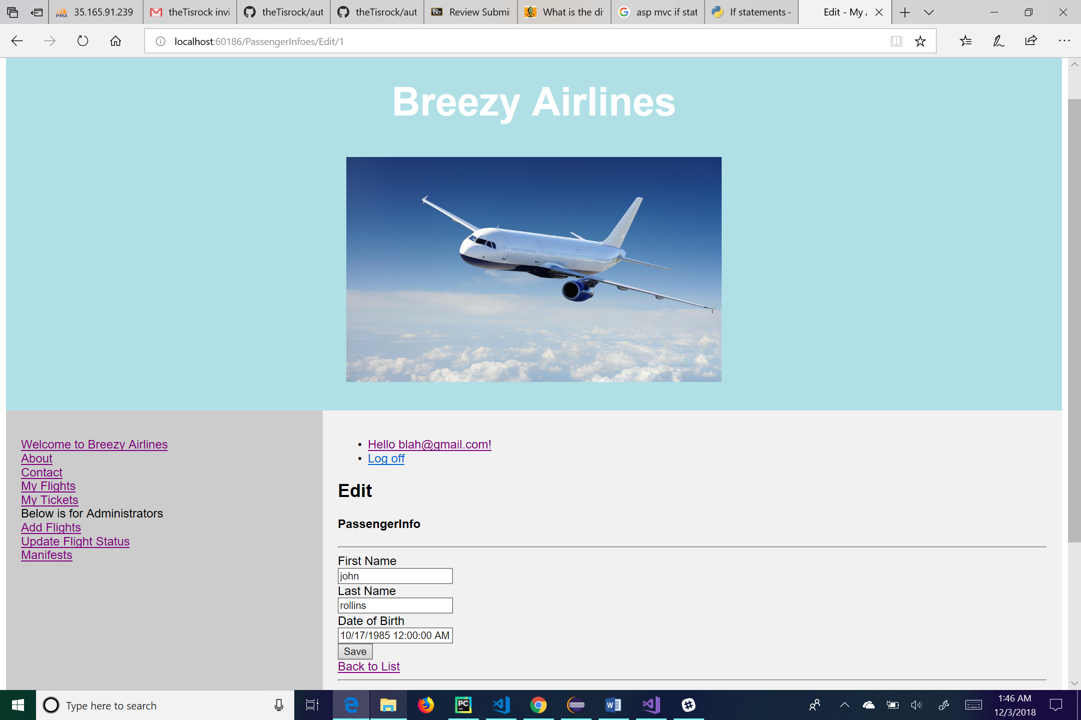

This is the edit page for passenger information. The user can change any of the textboxes and hit the “Save” button to save his or her changes. The “Back to List” link will take the user back to the list of passenger information. From this page the user can also log off by clicking the “Log off” link, manage their account by clicking on the link of their email, go to the main page by clicking the “Welcome to Breezy Airlines” link, go to his or her flights by clicking the “My Flights” link, go to his or her tickets by clicking the “My Tickets” link, go to the about page by clicking the “About” link, or go to the contact page by clicking the “Contact” link. For administrative use, the user can click on the “Add Flights” link to add a flight to the database, click on the “Update Flight Status” link to change a flight status, or click on the “Manifests” link to see a manifest of the flight.

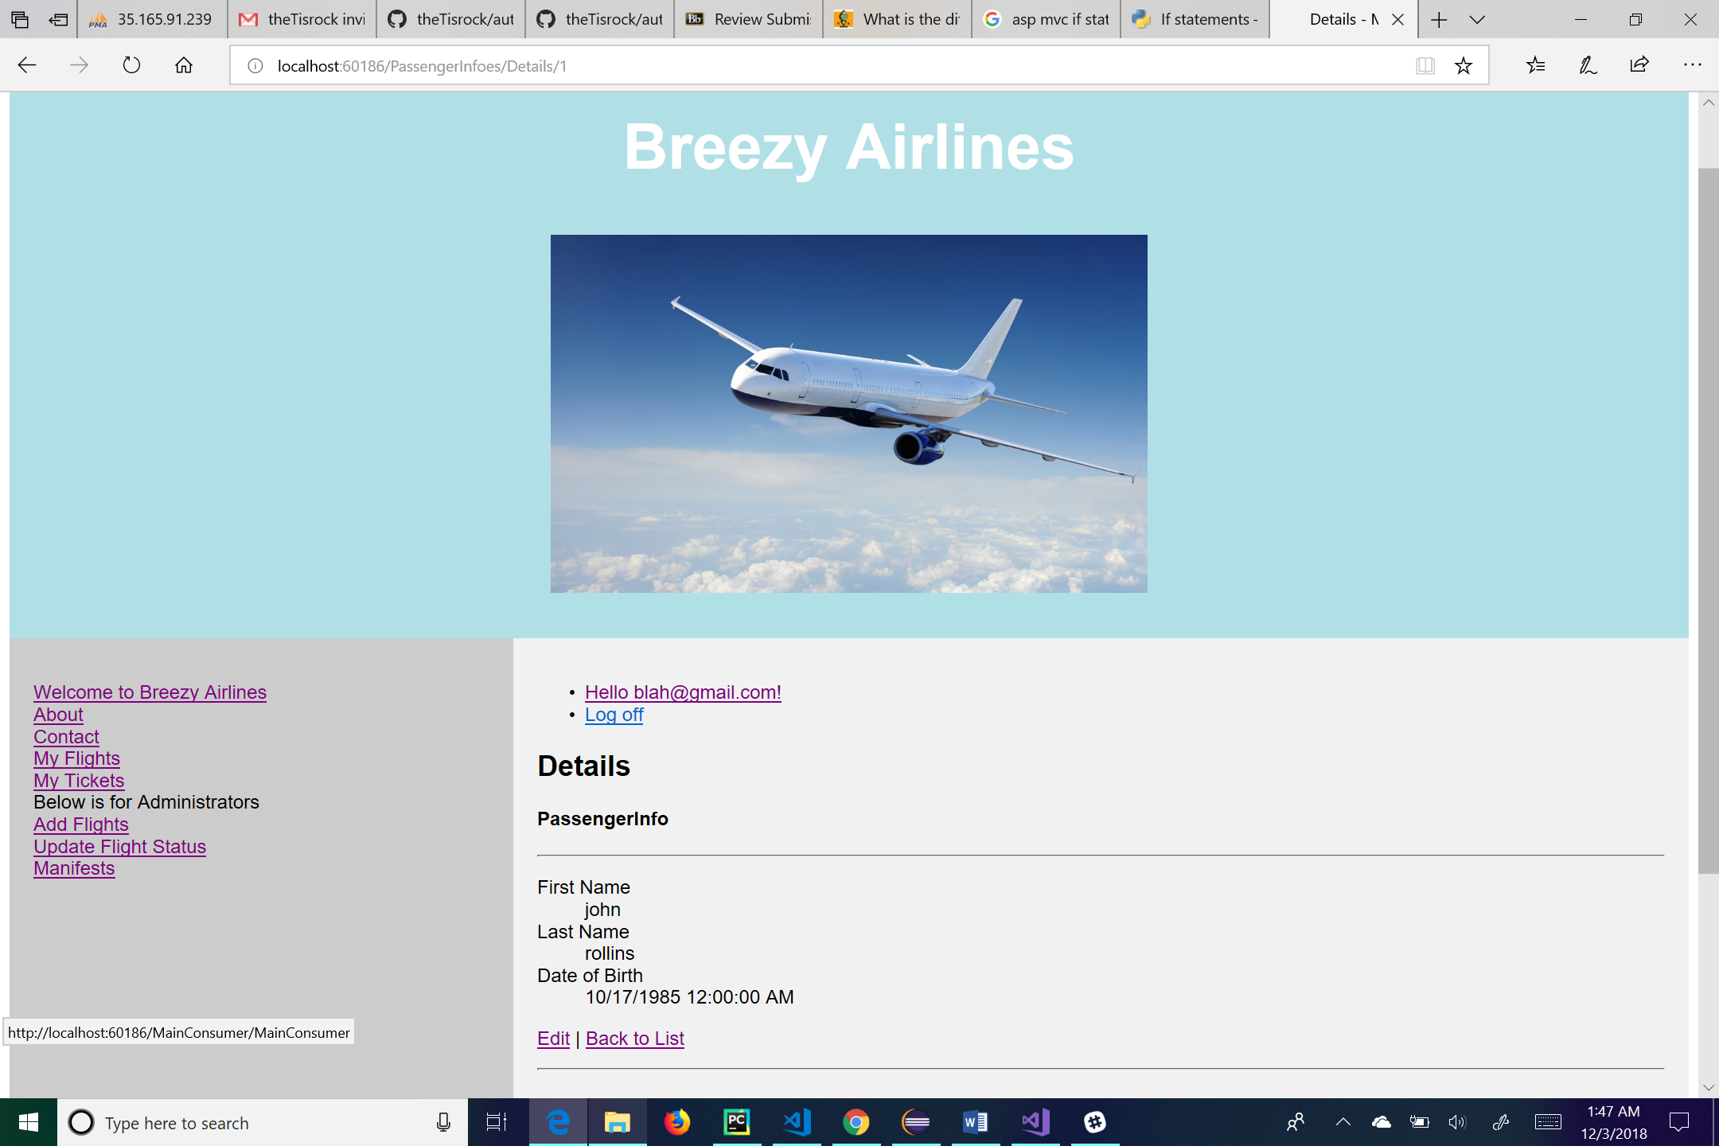

This is the details page for the passenger information. Here the user can see the details of the passenger information that he or she clicks on. The “Edit” link at the bottom of the page will take the user to the edit page for that particular passenger information. The “Back to List” link will take the user back to the list of passenger information. From this page the user can also log off by clicking the “Log off” link, manage their account by clicking on the link of their email, go to the main page by clicking the “Welcome to Breezy Airlines” link, go to his or her flights by clicking the “My Flights” link, go to his or her tickets by clicking the “My Tickets” link, go to the about page by clicking the “About” link, or go to the contact page by clicking the “Contact” link. For administrative use, the user can click on the “Add Flights” link to add a flight to the database, click on the “Update Flight Status” link to change a flight status, or click on the “Manifests” link to see a manifest of the flight.

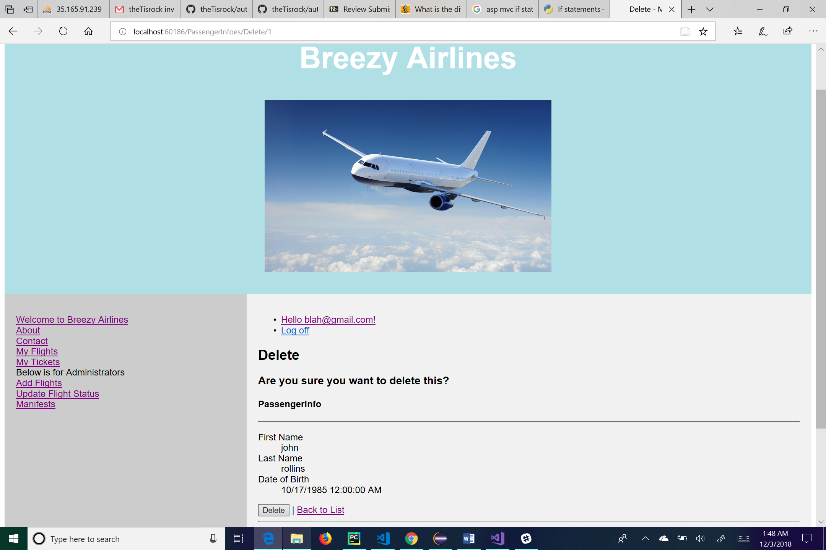

This is the delete page for passenger information. This page allows the user to delete a specific user’s passenger information. Clicking the “Delete” button on the bottom of the page will delete the user’s passenger information from the system. The “Back to List” link will take the user back to the list of passenger information. From this page the user can also log off by clicking the “Log off” link, manage their account by clicking on the link of their email, go to the main page by clicking the “Welcome to Breezy Airlines” link, go to his or her flights by clicking the “My Flights” link, go to his or her tickets by clicking the “My Tickets” link, go to the about page by clicking the “About” link, or go to the contact page by clicking the “Contact” link. For administrative use, the user can click on the “Add Flights” link to add a flight to the database, click on the “Update Flight Status” link to change a flight status, or click on the “Manifests” link to see a manifest of the flight.

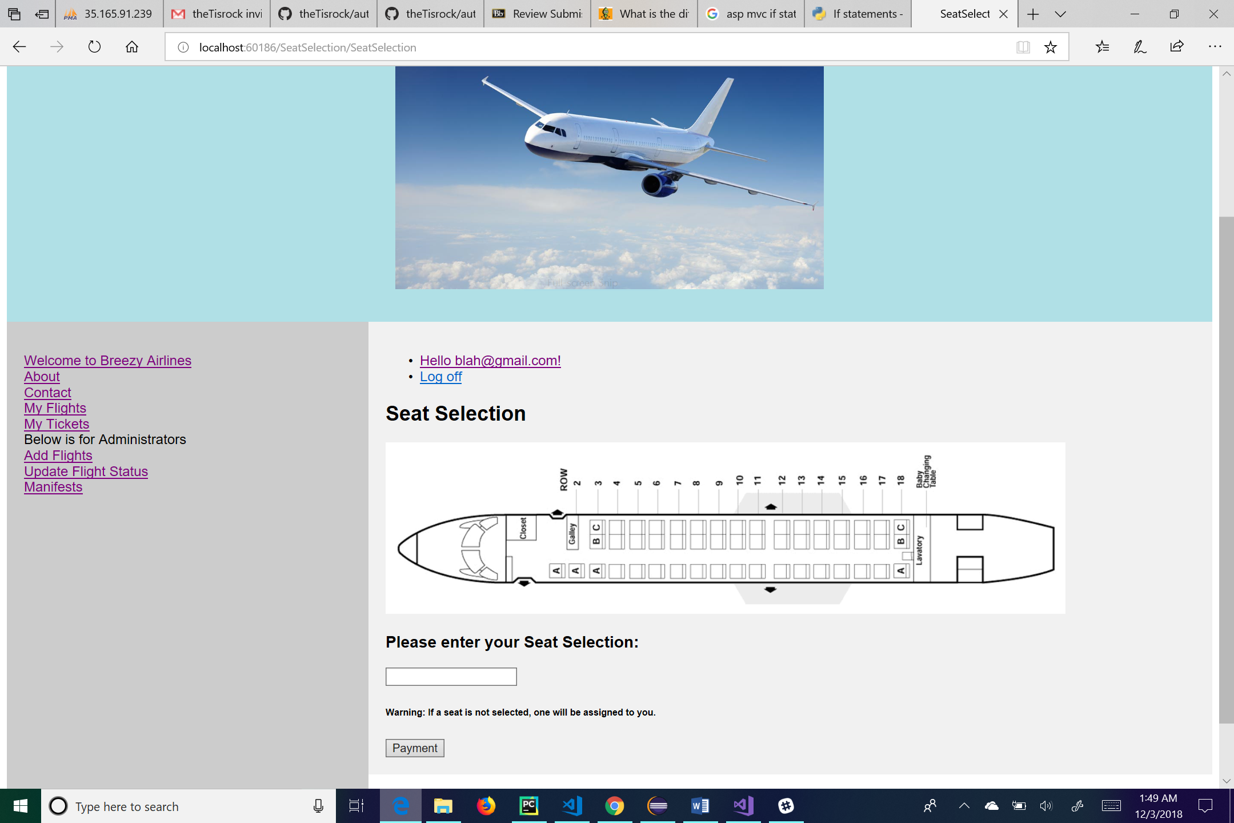

This is the seat selection page. From here the user can log off by clicking the “Log off” link, manage their account by clicking on the link of their email, go to the main page by clicking the “Welcome to Breezy Airlines” link, go to his or her flights by clicking the “My Flights” link, go to his or her tickets by clicking the “My Tickets” link, go to the about page by clicking the “About” link, or go to the contact page by clicking the “Contact” link. For administrative use, the user can click on the “Add Flights” link to add a flight to the database, click on the “Update Flight Status” link to change a flight status, or click on the “Manifests” link to see a manifest of the flight. On this page, the user will select the seat that they wish to sit in. They can look on the map provided and type the seat they wish to select into the textbox. Once they have their seat selected, they will click the payment button which will take them to the payment page.

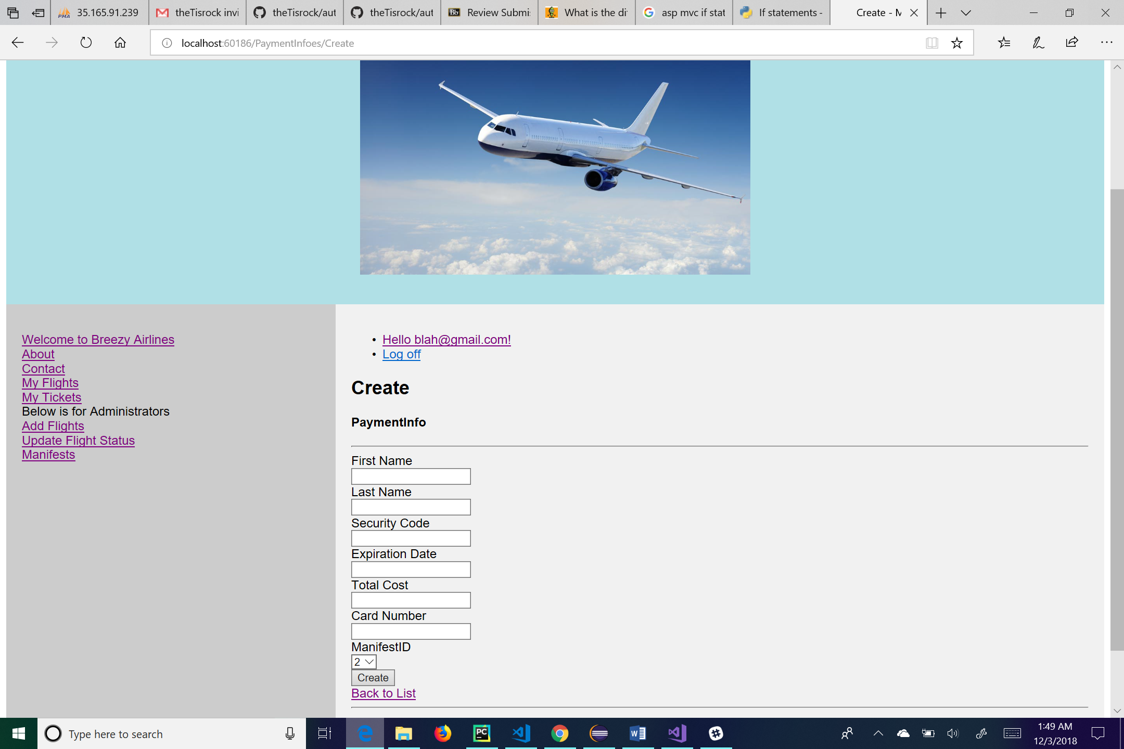

This is the create page for the payment information of the user. Her the user will enter in all his or her information into the respective textboxes. The Manifest Id is a dropdown list for the user to choose from. Once the user has completed all the required fields, he or she will click create to put his or her information into the system. From this page the user can log off by clicking the “Log off” link, manage their account by clicking on the link of their email, go to the main page by clicking the “Welcome to Breezy Airlines” link, go to his or her flights by clicking the “My Flights” link, go to his or her tickets by clicking the “My Tickets” link, go to the about page by clicking the “About” link, or go to the contact page by clicking the “Contact” link. For administrative use, the user can click on the “Add Flights” link to add a flight to the database, click on the “Update Flight Status” link to change a flight status, or click on the “Manifests” link to see a manifest of the flight. There is also a link for the user to go “Back to List”, this will take the user to a list of different payment information.

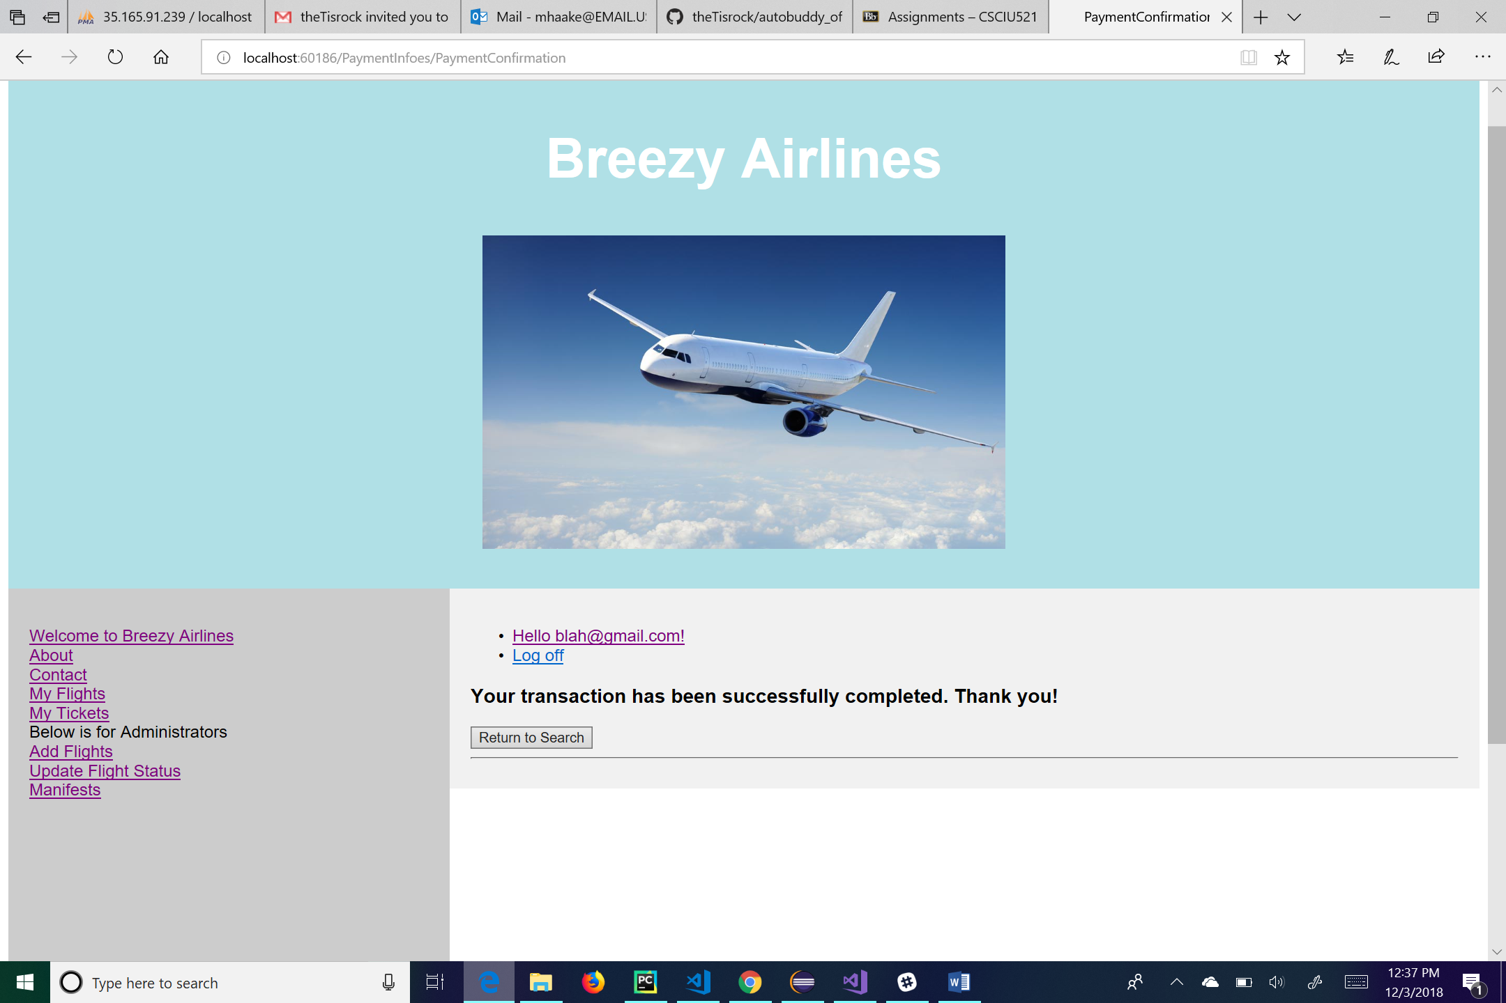

After the user enters in his or her payment information, he or she will be taken to this confirmation page. There is a button at the bottom labeled “Return to Search” which takes you back to the main searching for a flight page. From this page the user can also log off by clicking the “Log off” link, manage their account by clicking on the link of their email, go to the main page by clicking the “Welcome to Breezy Airlines” link, go to his or her flights by clicking the “My Flights” link, go to his or her tickets by clicking the “My Tickets” link, go to the about page by clicking the “About” link, or go to the contact page by clicking the “Contact” link. For administrative use, the user can click on the “Add Flights” link to add a flight to the database, click on the “Update Flight Status” link to change a flight status, or click on the “Manifests” link to see a manifest of the flight.

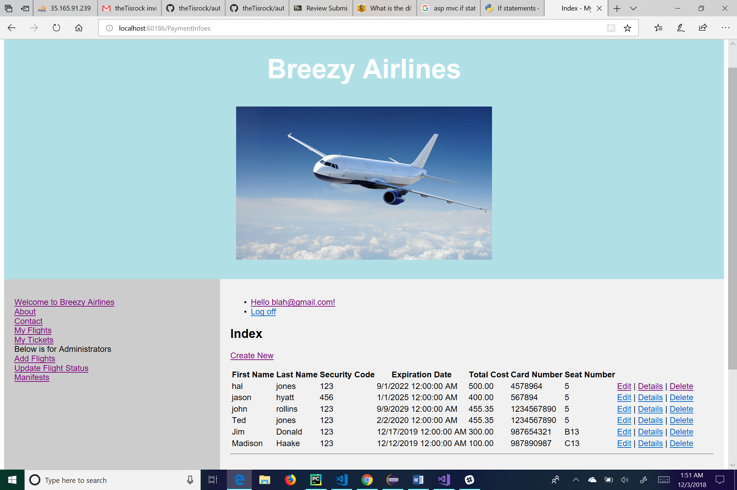

This is the payment information page which can only be seen by an administrator and is only for administrative use. This page shows a list of all the payment information that has been created. There is a link for the administrator to create a new user above the list which takes him or her to the create page for payment information. The links next to each user’s payment information take the administrator to “Edit”, “Details”, and “Delete” pages for that user. From this page the administrator can also log off by clicking the “Log off” link, manage their account by clicking on the link of their email, go to the main page by clicking the “Welcome to Breezy Airlines” link, go to his or her flights by clicking the “My Flights” link, go to his or her tickets by clicking the “My Tickets” link, go to the about page by clicking the “About” link, or go to the contact page by clicking the “Contact” link. The administrator can click on the “Add Flights” link to add a flight to the database, click on the “Update Flight Status” link to change a flight status, or click on the “Manifests” link to see a manifest of the flight.

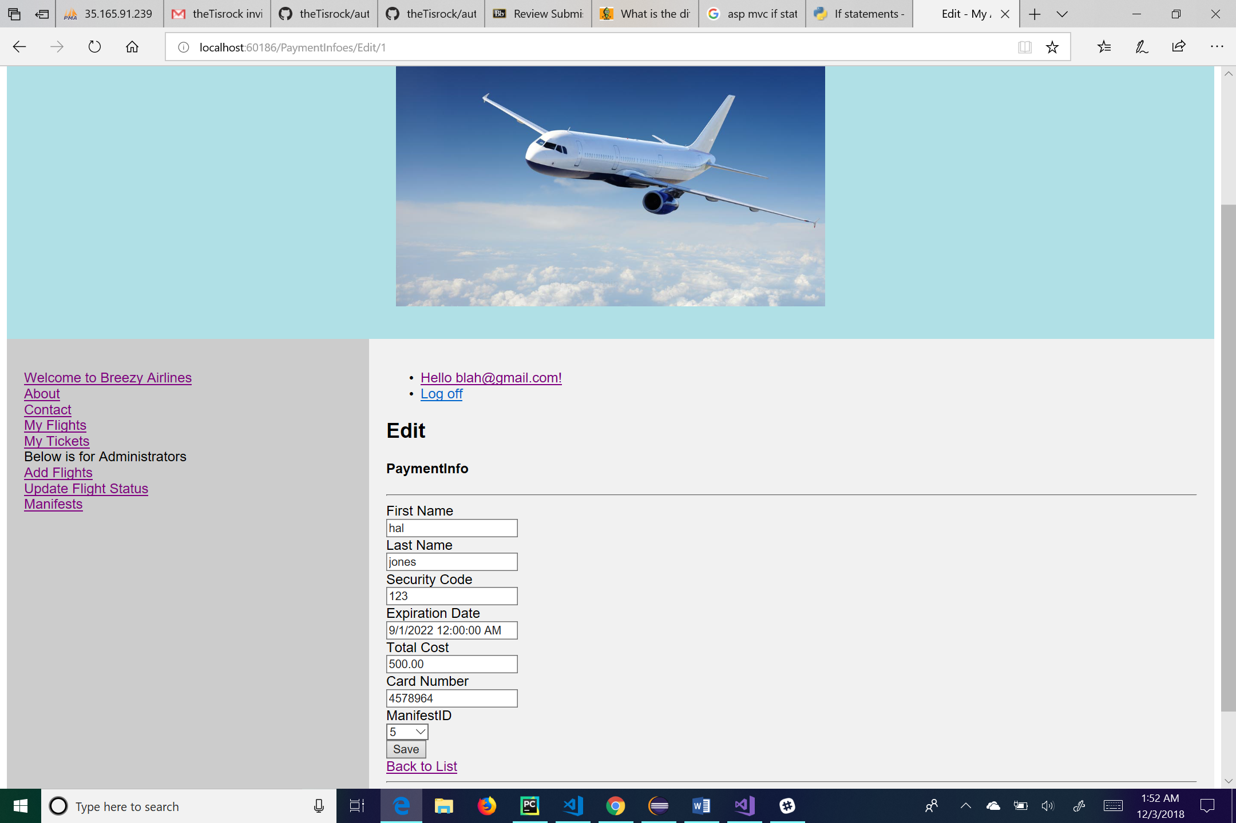

This is the edit page for payment information. The administrator can change any of the textboxes or dropdown box and hit the “Save” button to save his or her changes. The “Back to List” link will take the administrator back to the list of payment information. From this page the administrator can also log off by clicking the “Log off” link, manage their account by clicking on the link of their email, go to the main page by clicking the “Welcome to Breezy Airlines” link, go to his or her flights by clicking the “My Flights” link, go to his or her tickets by clicking the “My Tickets” link, go to the about page by clicking the “About” link, or go to the contact page by clicking the “Contact” link. He or she can also click on the “Add Flights” link to add a flight to the database, click on the “Update Flight Status” link to change a flight status, or click on the “Manifests” link to see a manifest of the flight.

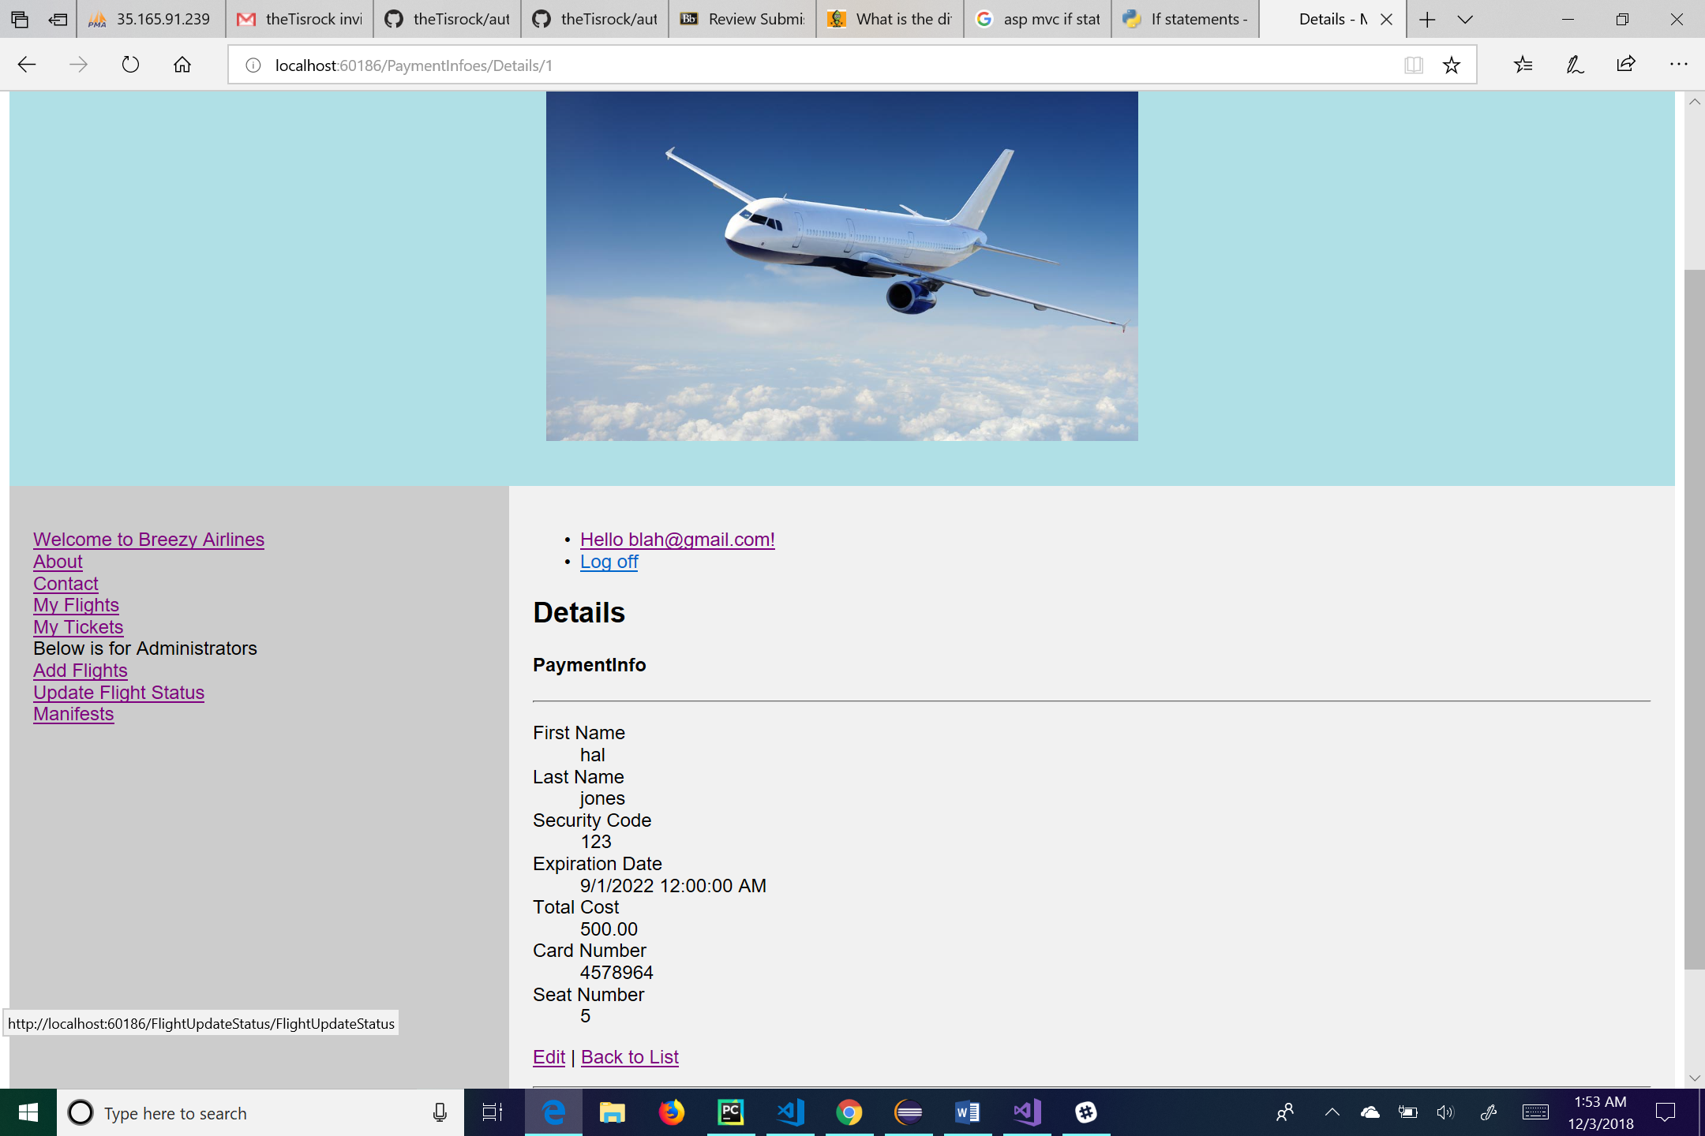

This is the details page for the payment information. Here the administrator can see the details of the payment information that he or she clicks on. The “Edit” link at the bottom of the page will take the user to the edit page for that particular payment information. The “Back to List” link will take the administrator back to the list of payment information. From this page the administrator can also log off by clicking the “Log off” link, manage their account by clicking on the link of their email, go to the main page by clicking the “Welcome to Breezy Airlines” link, go to his or her flights by clicking the “My Flights” link, go to his or her tickets by clicking the “My Tickets” link, go to the about page by clicking the “About” link, or go to the contact page by clicking the “Contact” link. He or she can also click on the “Add Flights” link to add a flight to the database, click on the “Update Flight Status” link to change a flight status, or click on the “Manifests” link to see a manifest of the flight.

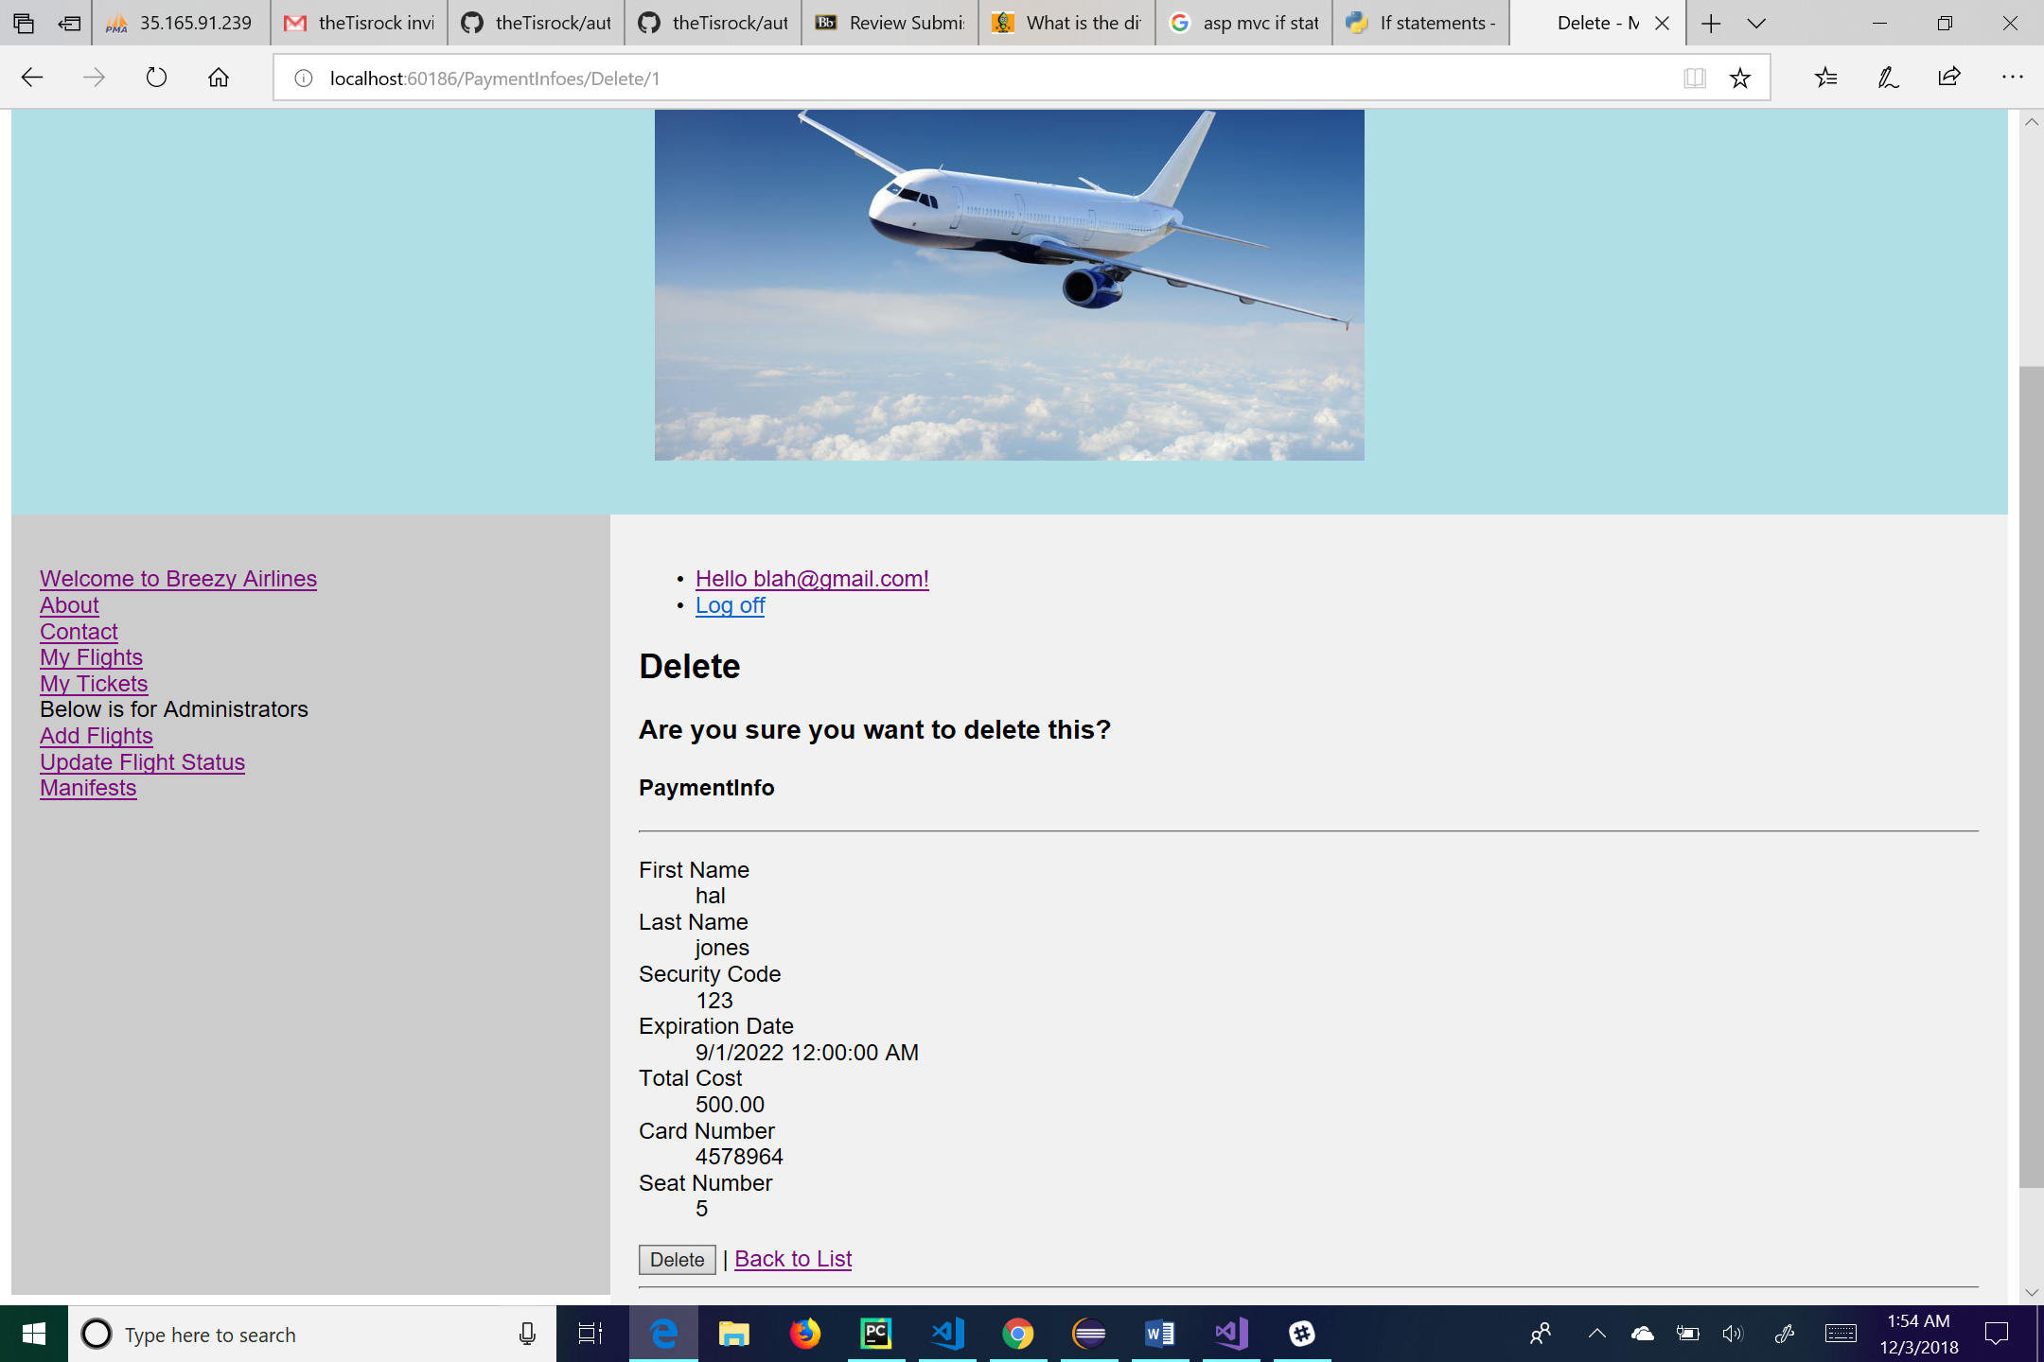

This is the delete page for payment information. This page allows the administrator to delete a specific user’s payment information. Clicking the “Delete” button on the bottom of the page will delete the user’s payment information from the system. The “Back to List” link will take the administrator back to the list of payment information. From this page the administrator can also log off by clicking the “Log off” link, manage their account by clicking on the link of their email, go to the main page by clicking the “Welcome to Breezy Airlines” link, go to his or her flights by clicking the “My Flights” link, go to his or her tickets by clicking the “My Tickets” link, go to the about page by clicking the “About” link, or go to the contact page by clicking the “Contact” link. He or she can also click on the “Add Flights” link to add a flight to the database, click on the “Update Flight Status” link to change a flight status, or click on the “Manifests” link to see a manifest of the flight.

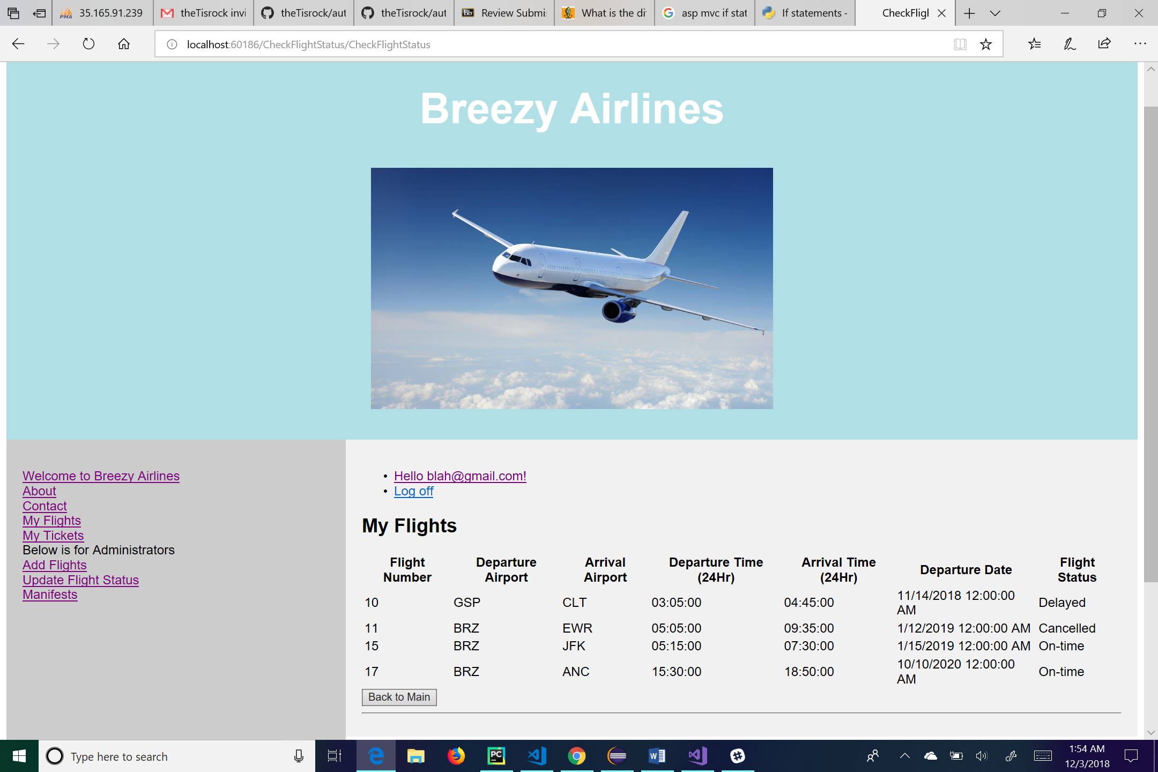

This is the My Flights page. The user will be taken to this page if he or she clicks on the “My Flights” link on the sidebar on the left. This page shows the user a list of all the flights the user has searched for. From here the user can log off by clicking the “Log off” link, manage their account by clicking on the link of their email, go to the main page by clicking the “Welcome to Breezy Airlines” link, go to his or her flights by clicking the “My Flights” link, go to his or her tickets by clicking the “My Tickets” link, go to the about page by clicking the “About” link, or go to the contact page by clicking the “Contact” link. For administrative use, the user can click on the “Add Flights” link to add a flight to the database, click on the “Update Flight Status” link to change a flight status, or click on the “Manifests” link to see a manifest of the flight. There is also a button on the bottom of the page to allow the user to go back to the main page.

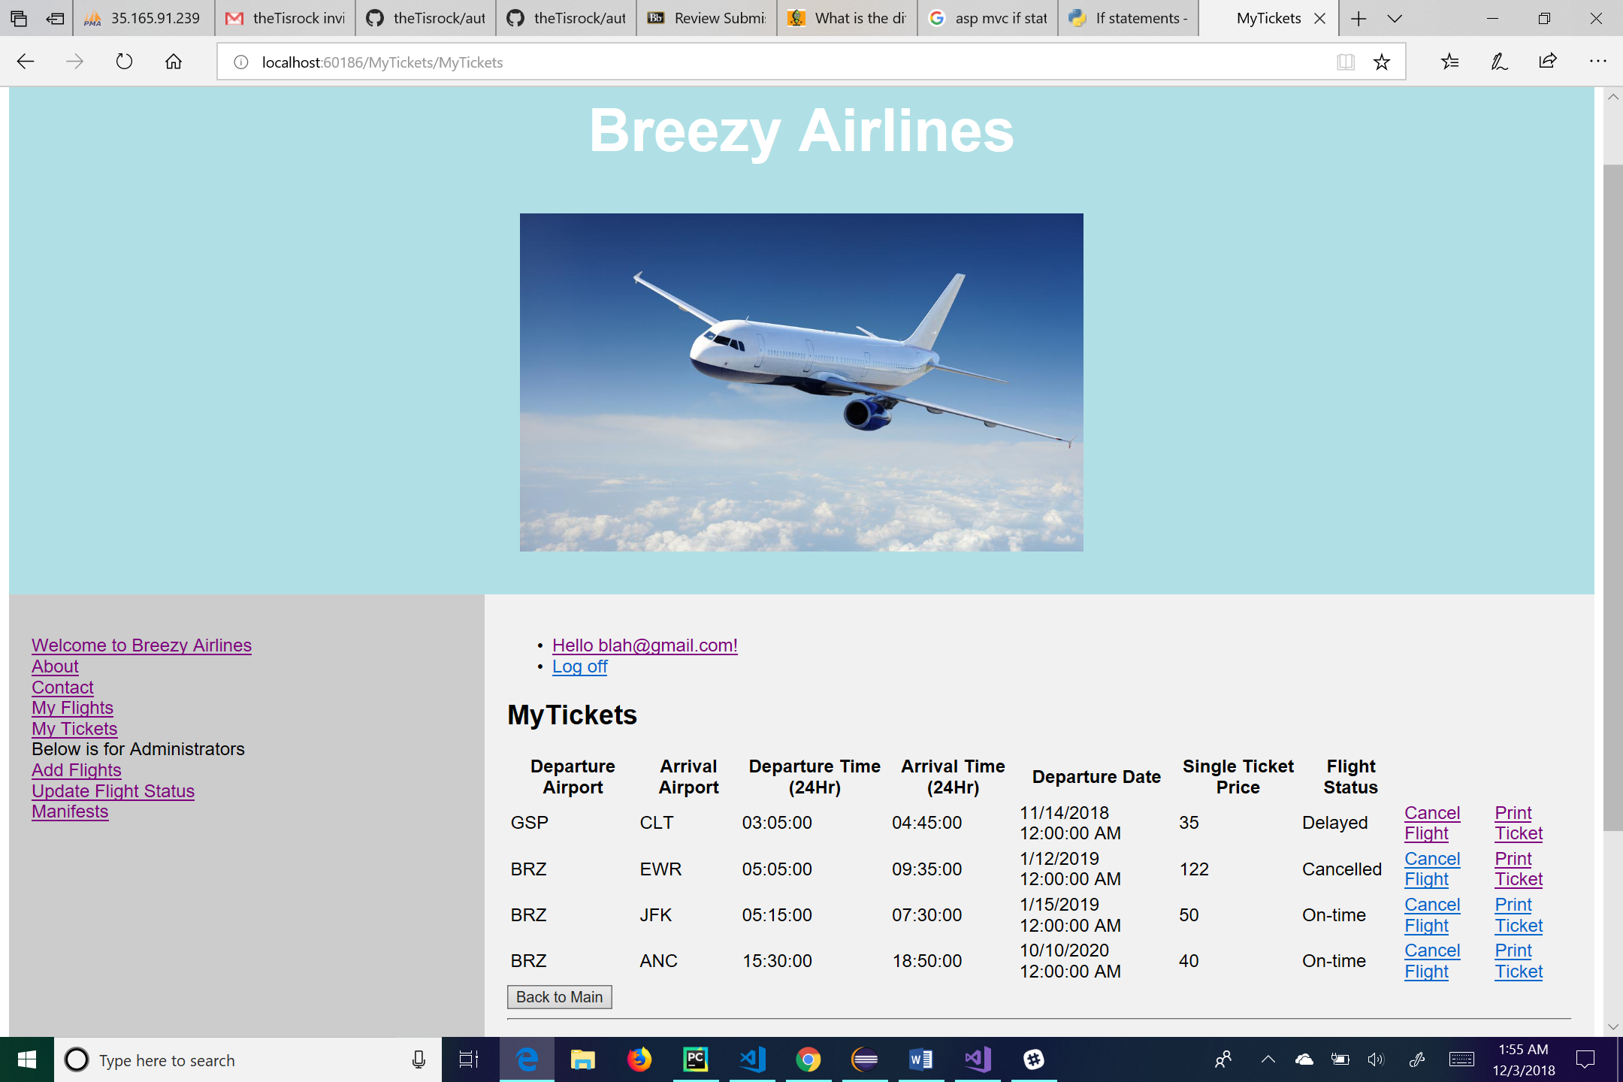

This is the My Tickets page. This will show all the tickets the user books. From here the user can log off by clicking the “Log off” link, manage their account by clicking on the link of their email, go to the main page by clicking the “Welcome to Breezy Airlines” link, go to his or her flights by clicking the “My Flights” link, go to his or her tickets by clicking the “My Tickets” link, go to the about page by clicking the “About” link, or go to the contact page by clicking the “Contact” link. For administrative use, the user can click on the “Add Flights” link to add a flight to the database, click on the “Update Flight Status” link to change a flight status, or click on the “Manifests” link to see a manifest of the flight. The user can also cancel his or her ticket by clicking on the link called “Cancel Flight” and print his or her ticket by clicking on the link called “Print Ticket”. There is also a button at the bottom of the page which allows the user to go back to the main page.

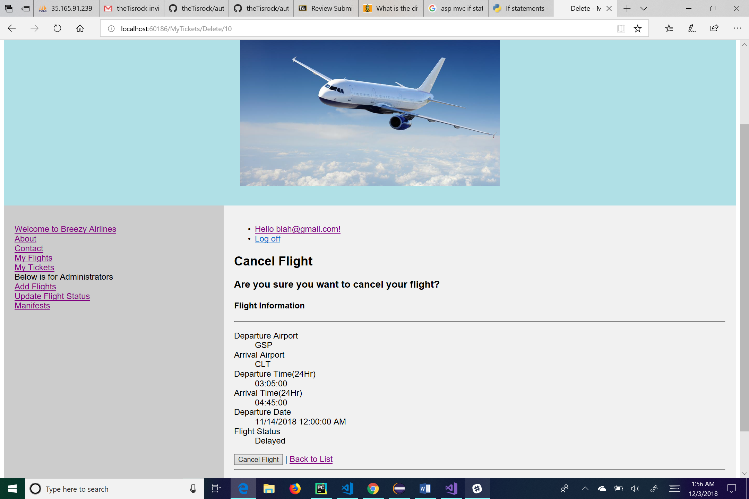

This is the cancel flight page. From here the user can log off by clicking the “Log off” link, manage their account by clicking on the link of their email, go to the main page by clicking the “Welcome to Breezy Airlines” link, go to his or her flights by clicking the “My Flights” link, go to his or her tickets by clicking the “My Tickets” link, go to the about page by clicking the “About” link, or go to the contact page by clicking the “Contact” link. For administrative use, the user can click on the “Add Flights” link to add a flight to the database, click on the “Update Flight Status” link to change a flight status, or click on the “Manifests” link to see a manifest of the flight. On this page the user is asked if he or she would like to cancel his or her flight for sure. If he or she does want to cancel the flight, he or she can click the button labeled “Cancel Flight”. If he or she does not want to actually cancel their flight, they can click the link labeled “Back to List” to be taken back to My Tickets.

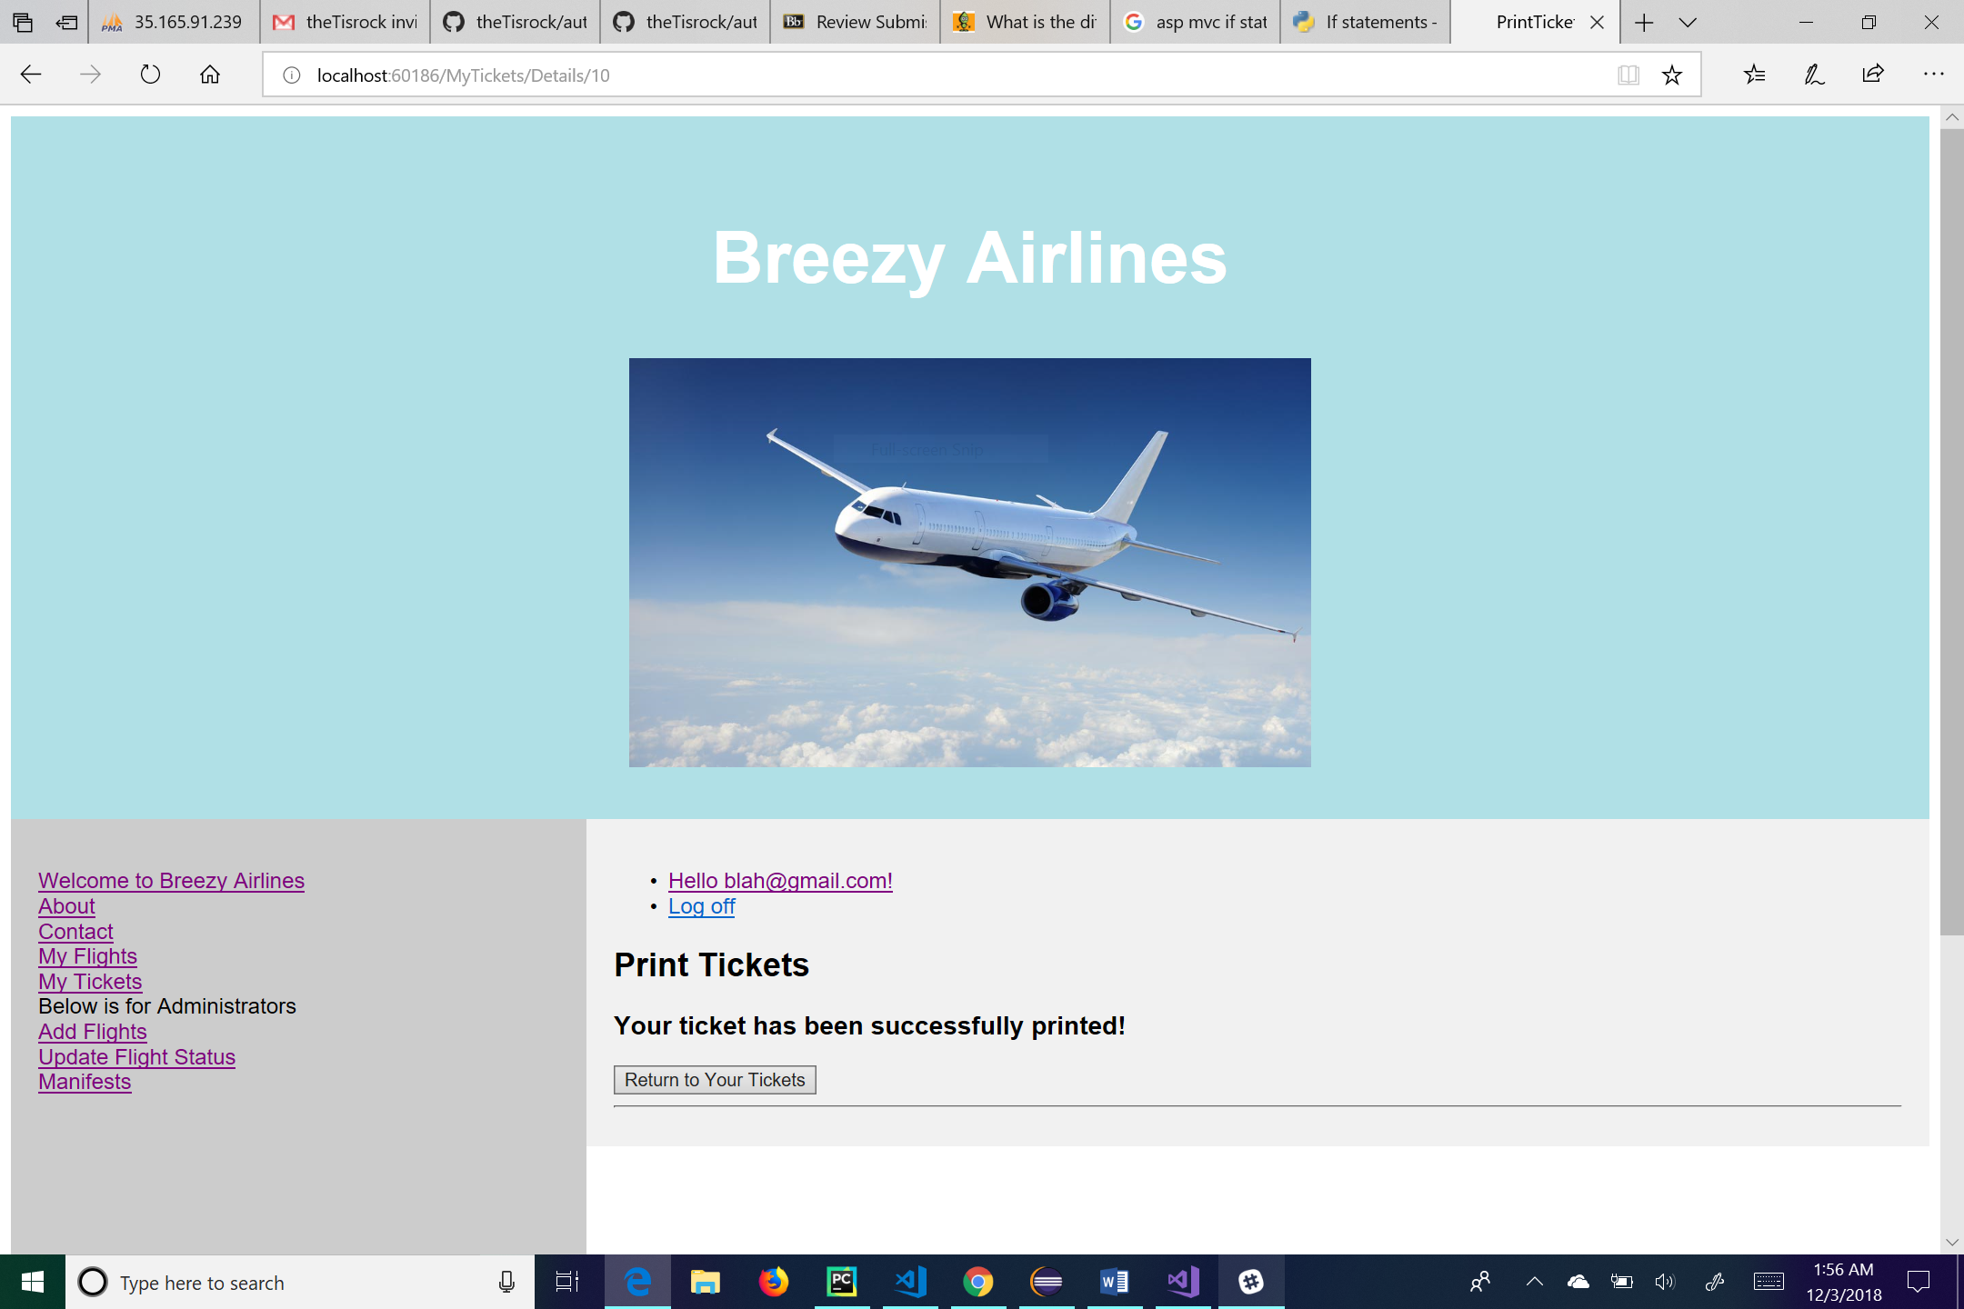

This is the print tickets page. When the user clicks on the link next to a specific ticket, he or she will be taken here. This page just tells the user that his or her ticket has been printed successfully. From here the user can log off by clicking the “Log off” link, manage their account by clicking on the link of their email, go to the main page by clicking the “Welcome to Breezy Airlines” link, go to his or her flights by clicking the “My Flights” link, go to his or her tickets by clicking the “My Tickets” link, go to the about page by clicking the “About” link, or go to the contact page by clicking the “Contact” link. For administrative use, the user can click on the “Add Flights” link to add a flight to the database, click on the “Update Flight Status” link to change a flight status, or click on the “Manifests” link to see a manifest of the flight. There is also a button at the bottom of the page for the user to be able to return to the My Tickets page.

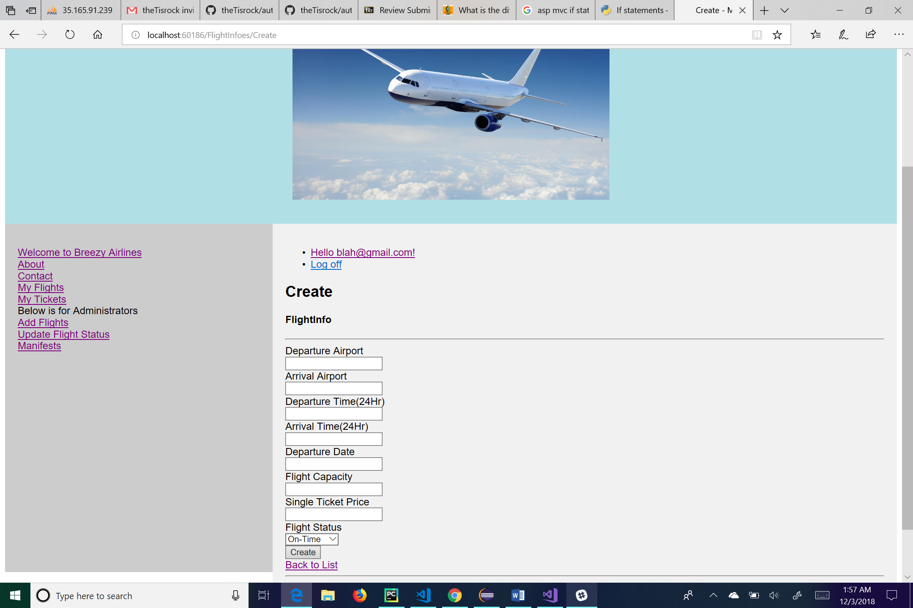

This is the create page for flight information. Her the user will enter in flight information into the respective textboxes. The Flight Status is a dropdown list for the user to choose from. Once the user has completed all the required fields, he or she will click create to put the flight information into the system. From this page the user can log off by clicking the “Log off” link, manage their account by clicking on the link of their email, go to the main page by clicking the “Welcome to Breezy Airlines” link, go to his or her flights by clicking the “My Flights” link, go to his or her tickets by clicking the “My Tickets” link, go to the about page by clicking the “About” link, or go to the contact page by clicking the “Contact” link. For administrative use, the user can click on the “Update Flight Status” link to change a flight status or click on the “Manifests” link to see a manifest of the flight. There is also a link for the user to go “Back to List”, this will take the user to a list of different flight information.

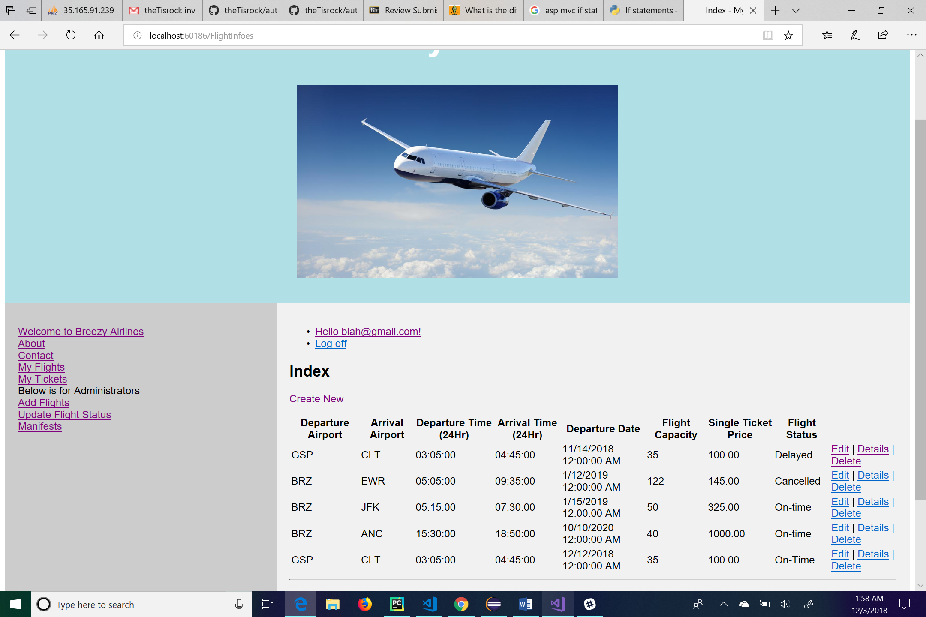

This is the flight information page. All information about a particular flight will be displayed here. There is a link for the user to create a new flight above the list which takes the user to the create page for flight information. The links next to each flight’s information take the user to “Edit”, “Details”, and “Delete” pages for that user. From this page the user can also log off by clicking the “Log off” link, manage their account by clicking on the link of their email, go to the main page by clicking the “Welcome to Breezy Airlines” link, go to his or her flights by clicking the “My Flights” link, go to his or her tickets by clicking the “My Tickets” link, go to the about page by clicking the “About” link, or go to the contact page by clicking the “Contact” link. For administrative use, the user can click on the “Add Flights” link to add a flight to the database, click on the “Update Flight Status” link to change a flight status, or click on the “Manifests” link to see a manifest of the flight.

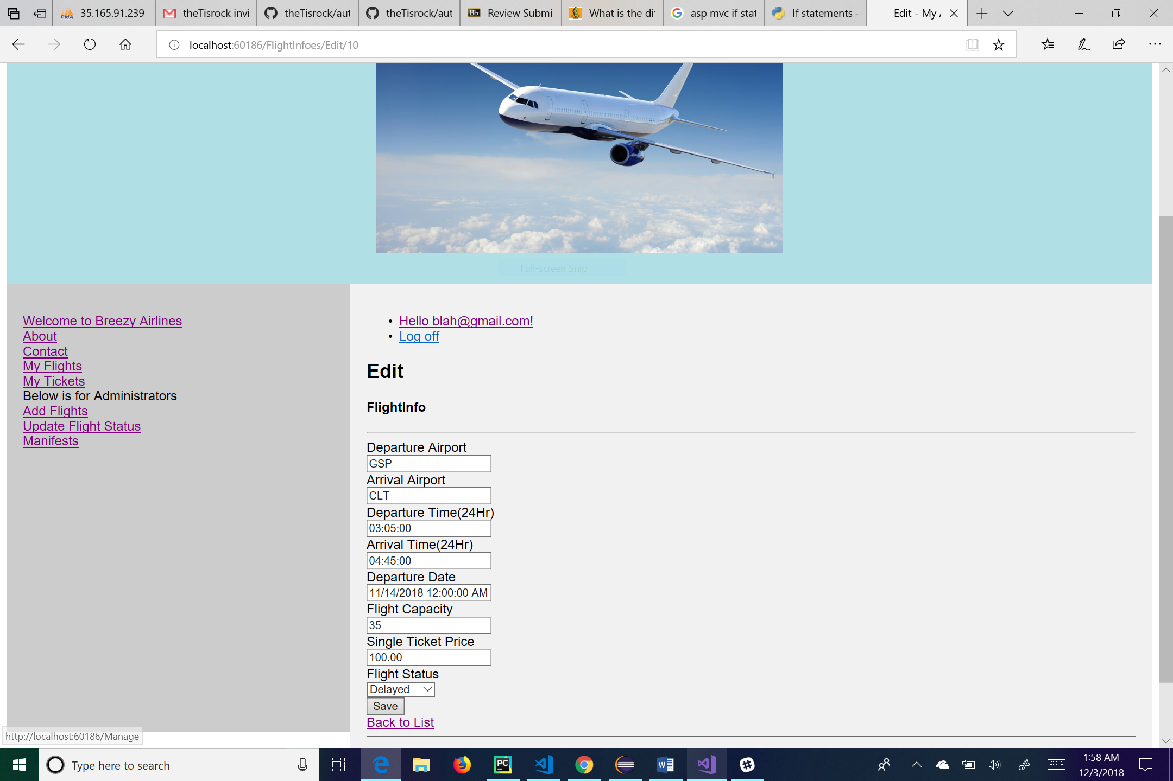

This is the edit page for flight information. The user can change any of the textboxes or dropdown box and hit the “Save” button to save his or her changes. The “Back to List” link will take the user back to the list of flight information. From this page the user can also log off by clicking the “Log off” link, manage their account by clicking on the link of their email, go to the main page by clicking the “Welcome to Breezy Airlines” link, go to his or her flights by clicking the “My Flights” link, go to his or her tickets by clicking the “My Tickets” link, go to the about page by clicking the “About” link, or go to the contact page by clicking the “Contact” link. For administrative use, the user can click on the “Add Flights” link to add a flight to the database, click on the “Update Flight Status” link to change a flight status, or click on the “Manifests” link to see a manifest of the flight.

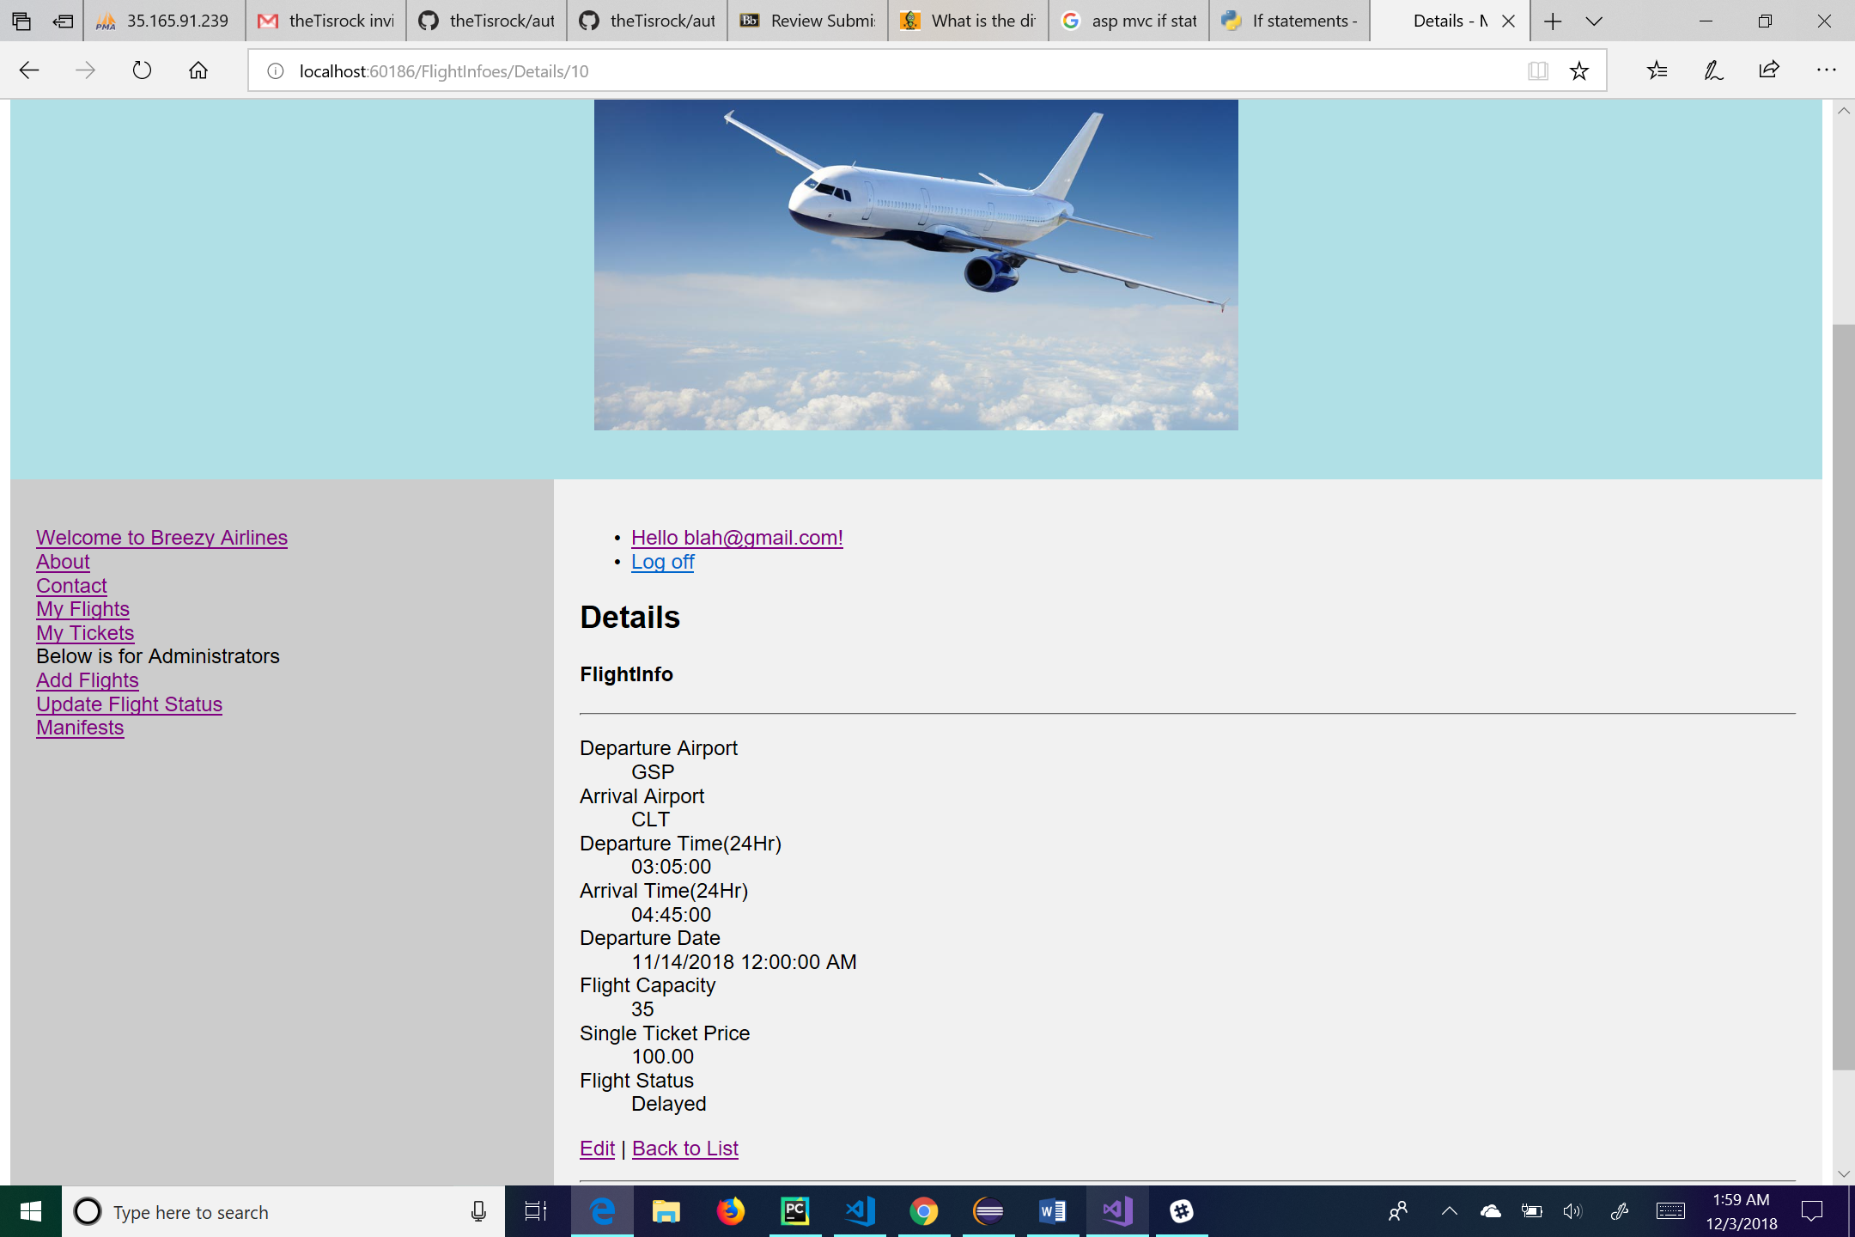

This is the details page for the flight information. Here the user can see the details of the flight information that he or she clicks on. The “Edit” link at the bottom of the page will take the user to the edit page for that particular flight. The “Back to List” link will take the user back to the list of flight information. From this page the user can also log off by clicking the “Log off” link, manage their account by clicking on the link of their email, go to the main page by clicking the “Welcome to Breezy Airlines” link, go to his or her flights by clicking the “My Flights” link, go to his or her tickets by clicking the “My Tickets” link, go to the about page by clicking the “About” link, or go to the contact page by clicking the “Contact” link. For administrative use, the user can click on the “Add Flights” link to add a flight to the database, click on the “Update Flight Status” link to change a flight status, or click on the “Manifests” link to see a manifest of the flight.

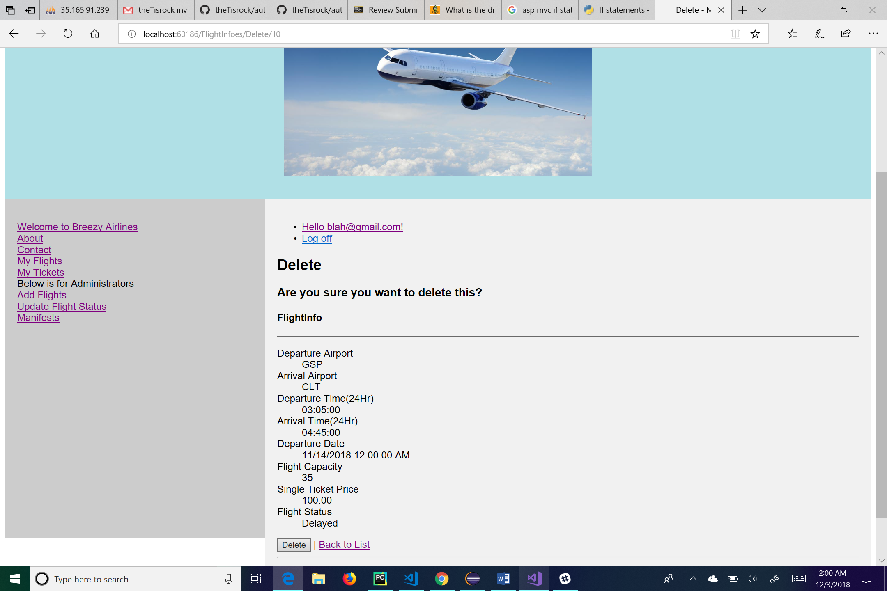

This is the delete page for flight information. This page allows the user to delete a specific flight. Clicking the “Delete” button on the bottom of the page will delete the flight from the system. The “Back to List” link will take the user back to the list of flight information. From this page the user can also log off by clicking the “Log off” link, manage their account by clicking on the link of their email, go to the main page by clicking the “Welcome to Breezy Airlines” link, go to his or her flights by clicking the “My Flights” link, go to his or her tickets by clicking the “My Tickets” link, go to the about page by clicking the “About” link, or go to the contact page by clicking the “Contact” link. For administrative use, the user can click on the “Add Flights” link to add a flight to the database, click on the “Update Flight Status” link to change a flight status, or click on the “Manifests” link to see a manifest of the flight.

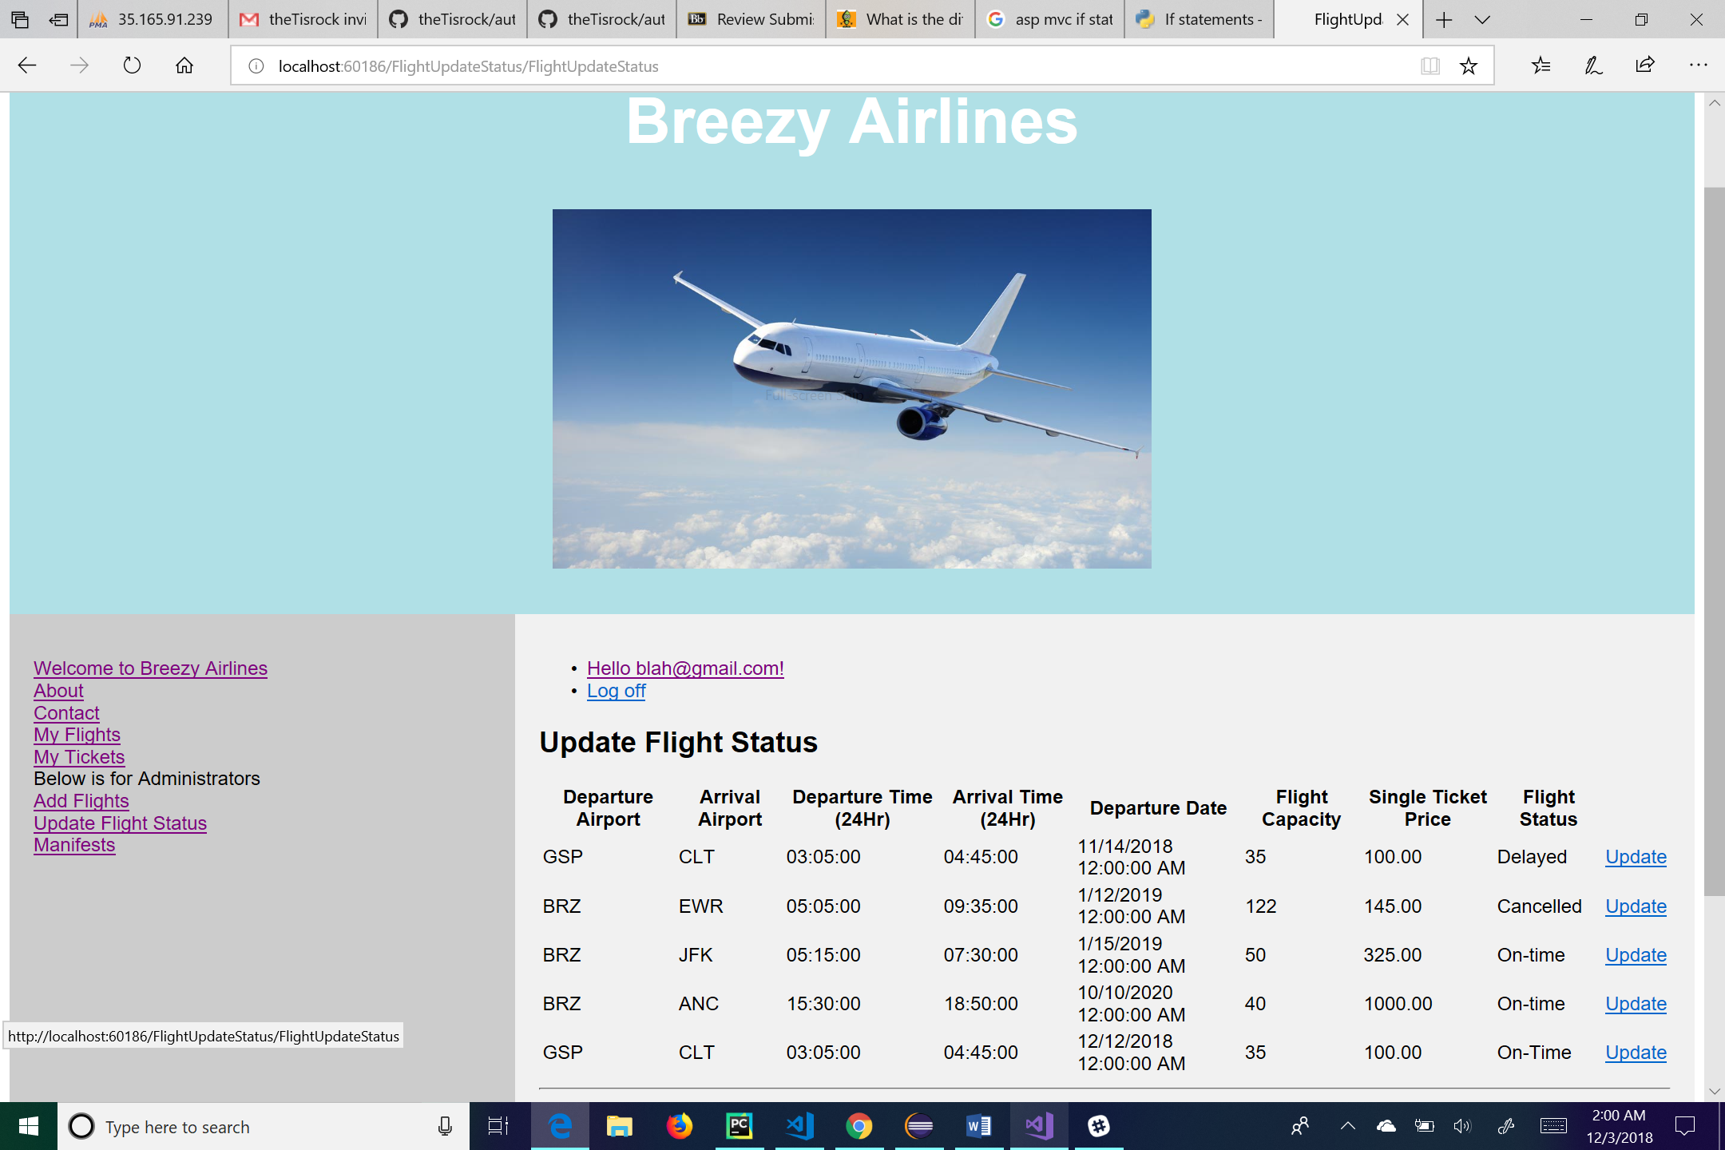

This is the update flight status page. Here the administrative user has the ability to update a flight status by clicking on the “Update” link next to the flight he or she wishes to update. From this page the user can also log off by clicking the “Log off” link, manage their account by clicking on the link of their email, go to the main page by clicking the “Welcome to Breezy Airlines” link, go to his or her flights by clicking the “My Flights” link, go to his or her tickets by clicking the “My Tickets” link, go to the about page by clicking the “About” link, or go to the contact page by clicking the “Contact” link. For administrative use, the user can click on the “Add Flights” link to add a flight to the database or click on the “Manifests” link to see a manifest of the flight.

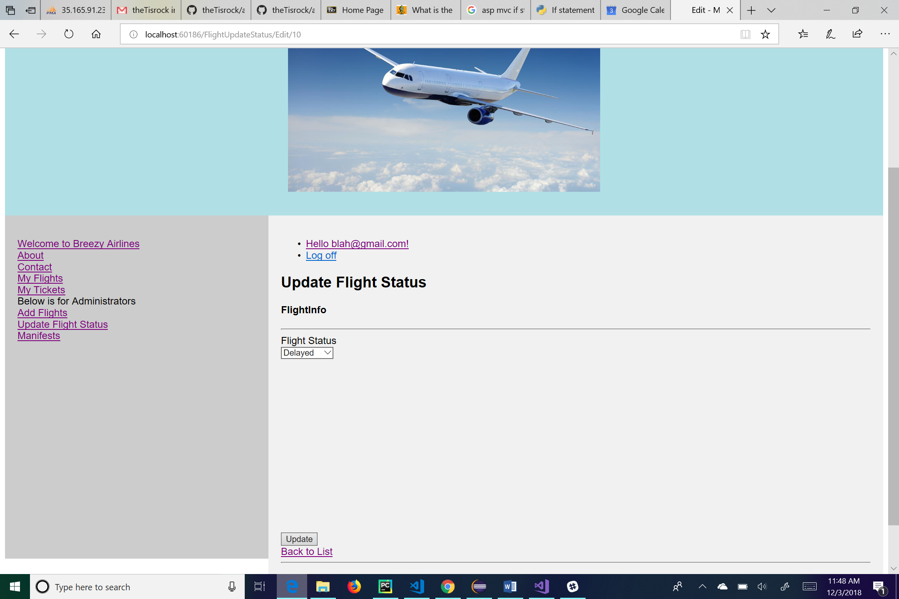

This is the update status page. This is the page where the administrative user will actually change the status of a certain flight. From the dropdown list, the user will choose the status of that flight and then click update to confirm and change the flight status. The “Back to List” link will take the user back to the list of flights. From this page the user can also log off by clicking the “Log off” link, manage their account by clicking on the link of their email, go to the main page by clicking the “Welcome to Breezy Airlines” link, go to his or her flights by clicking the “My Flights” link, go to his or her tickets by clicking the “My Tickets” link, go to the about page by clicking the “About” link, or go to the contact page by clicking the “Contact” link. For administrative use, the user can click on the “Add Flights” link to add a flight to the database, click on the “Update Flight Status” link to return to the list of flights, or click on the “Manifests” link to see a manifest of the flight.

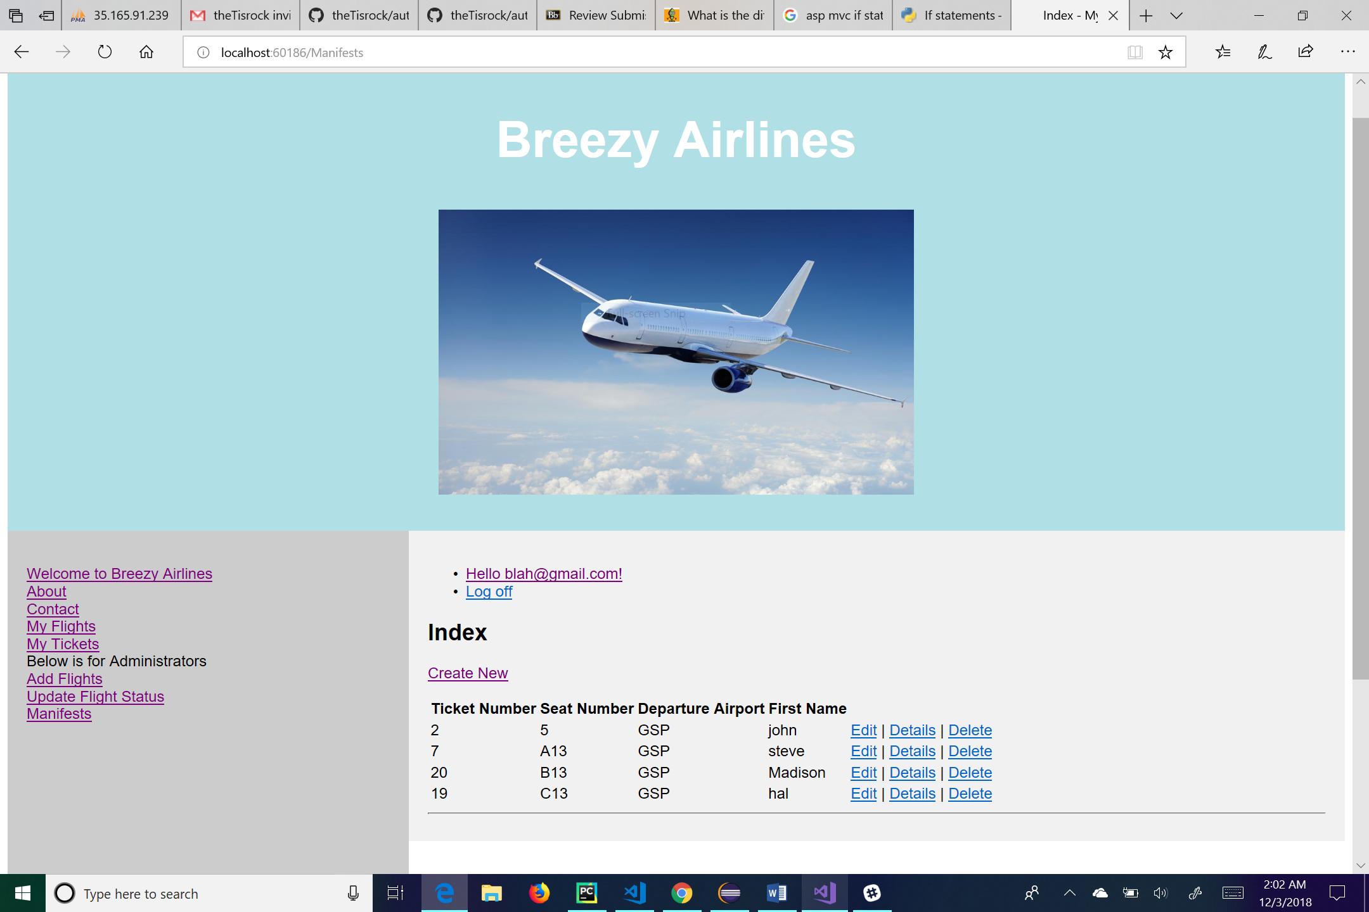

This is the manifest page. Here the administrative user can view the manifest for the flight. There is a link for the user to add someone to the manifest which takes the user to the create page for manifests. The links next to each manifest member’s information take the user to “Edit”, “Details”, and “Delete” pages for that user. From this page the user can also log off by clicking the “Log off” link, manage their account by clicking on the link of their email, go to the main page by clicking the “Welcome to Breezy Airlines” link, go to his or her flights by clicking the “My Flights” link, go to his or her tickets by clicking the “My Tickets” link, go to the about page by clicking the “About” link, or go to the contact page by clicking the “Contact” link. For administrative use, the user can click on the “Add Flights” link to add a flight to the database or click on the “Update Flight Status” link to change a flight status.

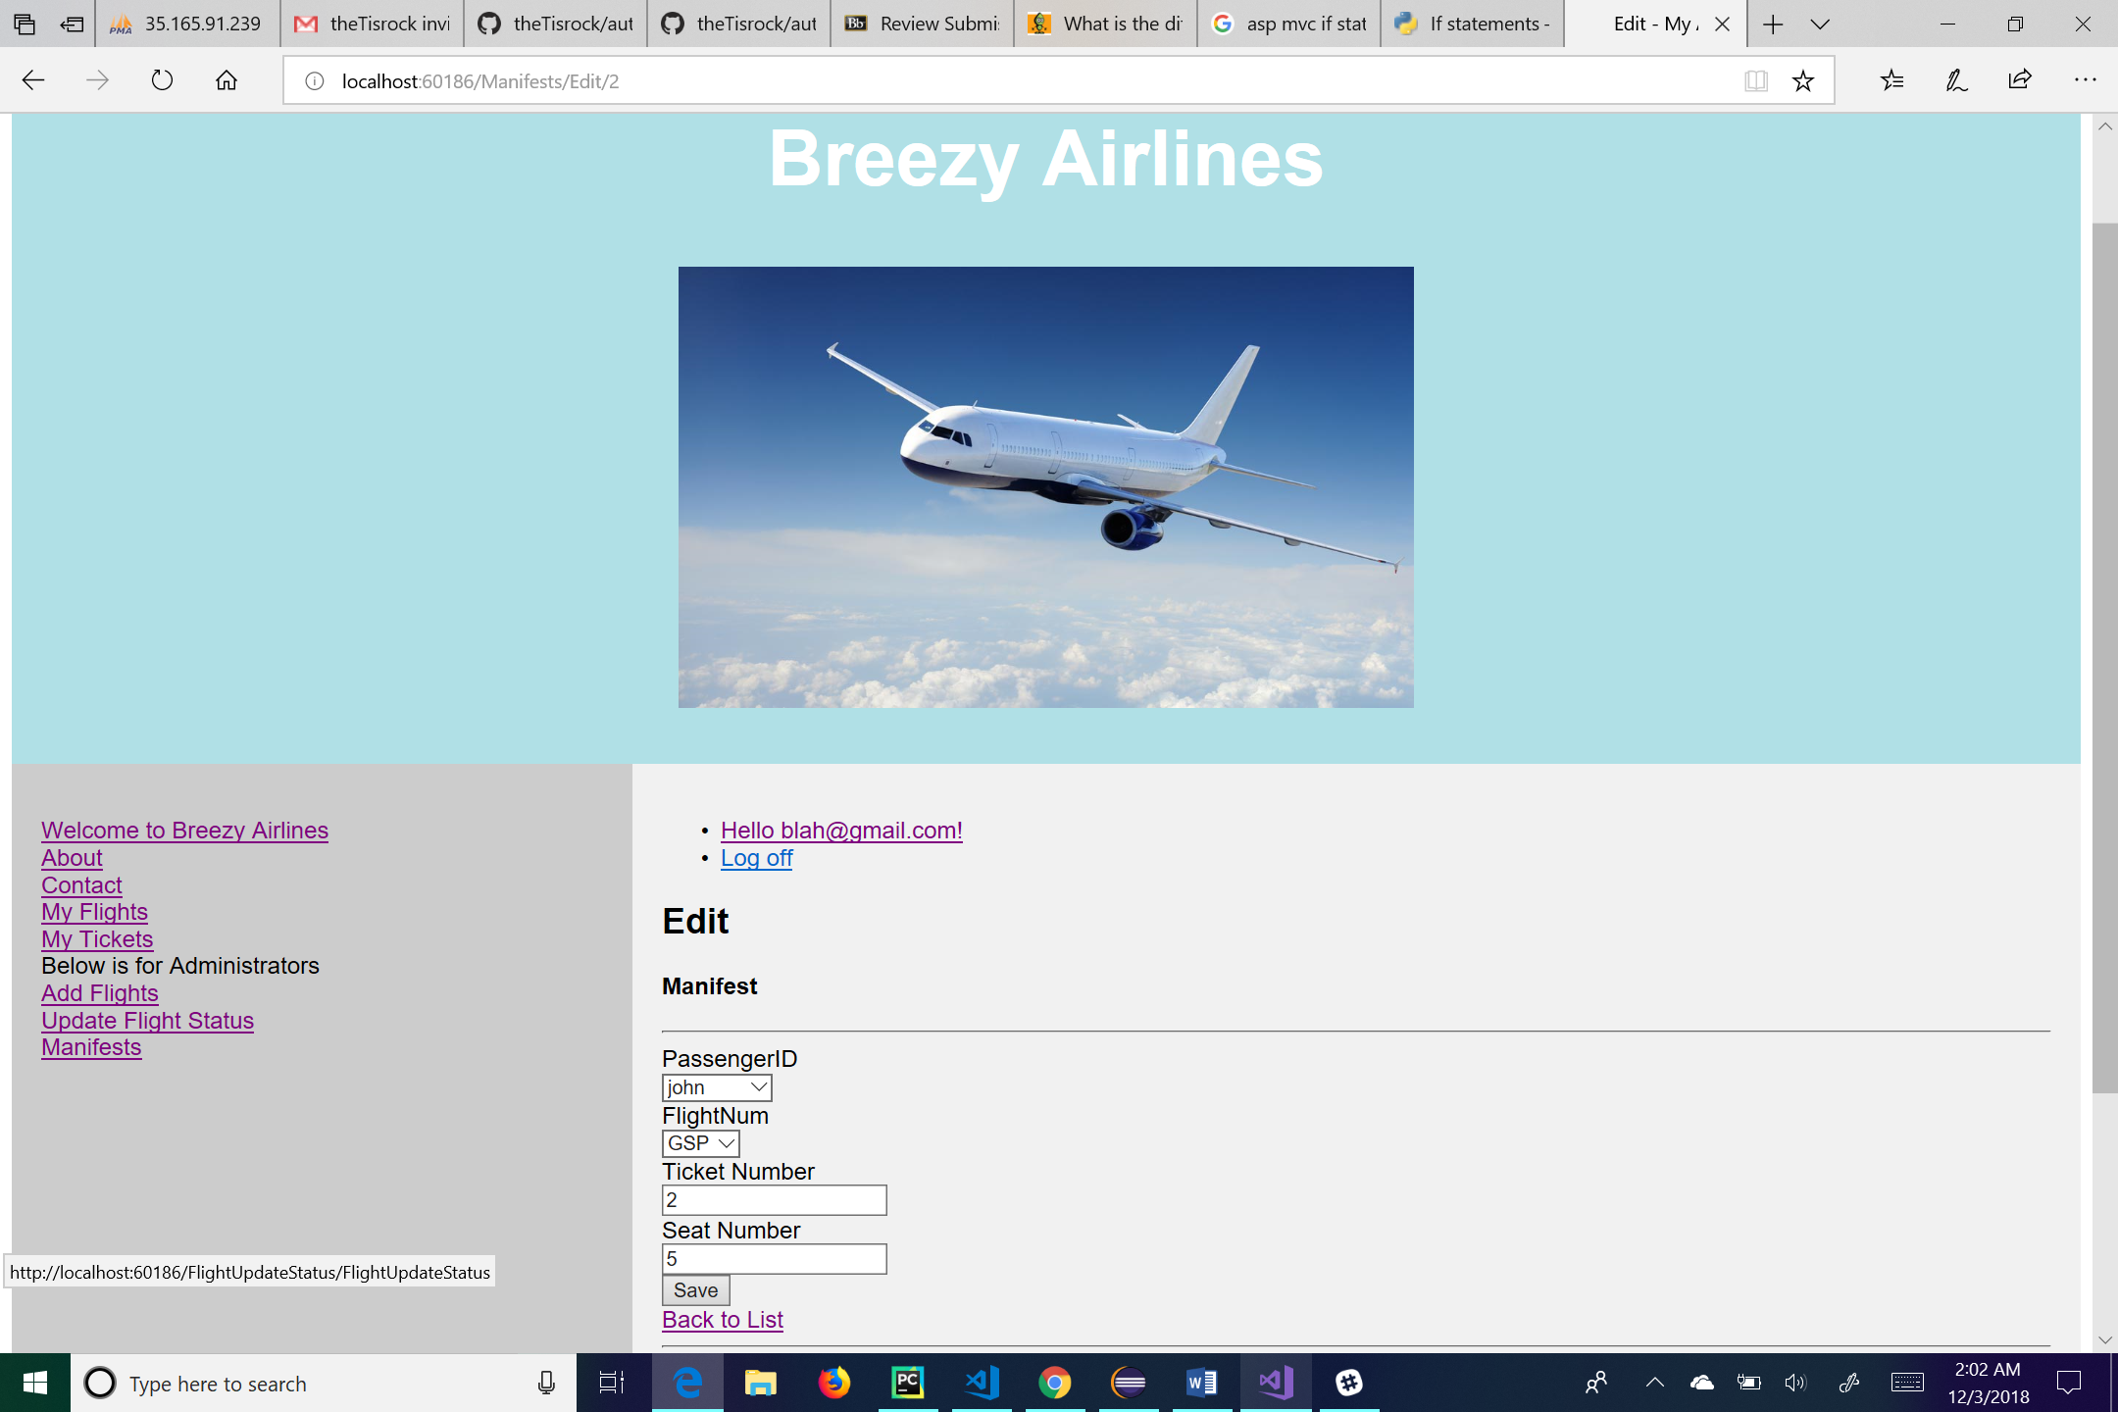

This is the edit page for manifest information. The user can change any of the textboxes or dropdown box and hit the “Save” button to save his or her changes. The “Back to List” link will take the user back to the list of manifest information. From this page the user can also log off by clicking the “Log off” link, manage their account by clicking on the link of their email, go to the main page by clicking the “Welcome to Breezy Airlines” link, go to his or her flights by clicking the “My Flights” link, go to his or her tickets by clicking the “My Tickets” link, go to the about page by clicking the “About” link, or go to the contact page by clicking the “Contact” link. For administrative use, the user can click on the “Add Flights” link to add a flight to the database, click on the “Update Flight Status” link to change a flight status, or click on the “Manifests” link to see a manifest of the flight.

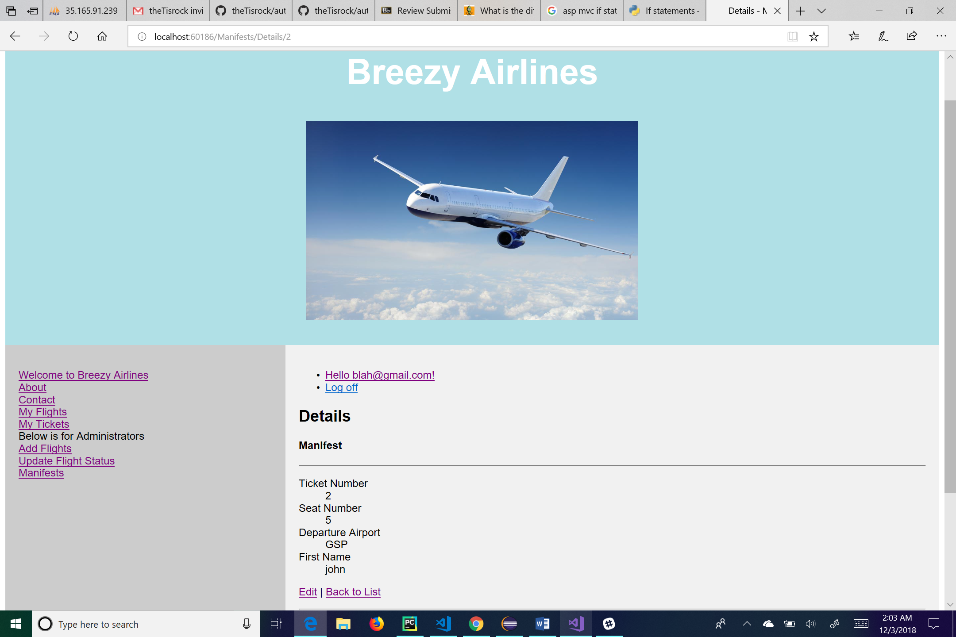

This is the details page for the manifest information. Here the user can see the details of the manifest information that he or she clicks on. The “Edit” link at the bottom of the page will take the user to the edit page for that particular manifest member. The “Back to List” link will take the user back to the list of manifest information. From this page the user can also log off by clicking the “Log off” link, manage their account by clicking on the link of their email, go to the main page by clicking the “Welcome to Breezy Airlines” link, go to his or her flights by clicking the “My Flights” link, go to his or her tickets by clicking the “My Tickets” link, go to the about page by clicking the “About” link, or go to the contact page by clicking the “Contact” link. For administrative use, the user can click on the “Add Flights” link to add a flight to the database, click on the “Update Flight Status” link to change a flight status, or click on the “Manifests” link to see a manifest of the flight.

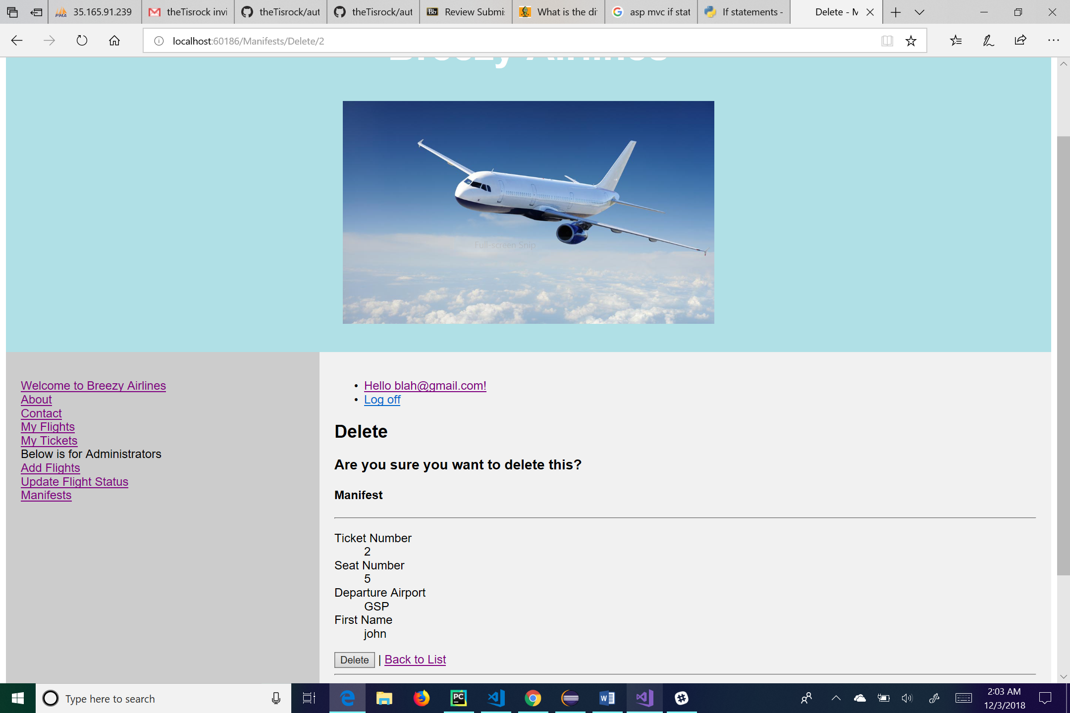

This is the delete page for manifest information. This page allows the user to delete a specific manifest member. Clicking the “Delete” button on the bottom of the page will delete the member from the system. The “Back to List” link will take the user back to the list of manifest information. From this page the user can also log off by clicking the “Log off” link, manage their account by clicking on the link of their email, go to the main page by clicking the “Welcome to Breezy Airlines” link, go to his or her flights by clicking the “My Flights” link, go to his or her tickets by clicking the “My Tickets” link, go to the about page by clicking the “About” link, or go to the contact page by clicking the “Contact” link. For administrative use, the user can click on the “Add Flights” link to add a flight to the database, click on the “Update Flight Status” link to change a flight status, or click on the “Manifests” link to see a manifest of the flight.

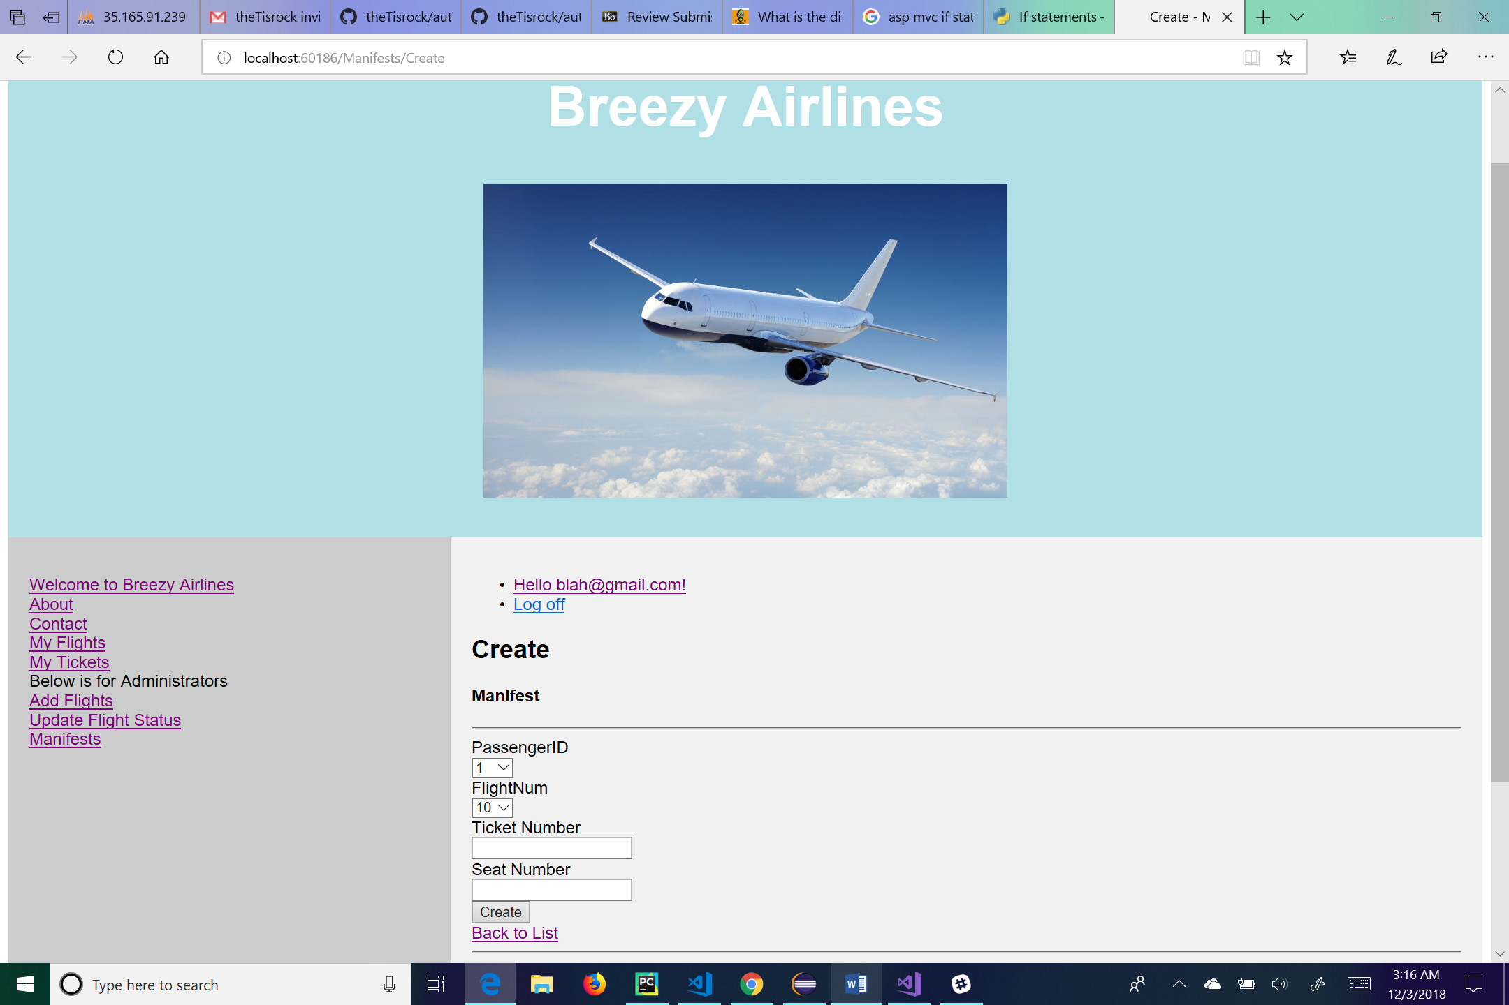

This is the create page for manifest information. Here the user will enter in manifest information into the respective textboxes and dropdown boxes. Once the user has completed all the required fields, he or she will click create to put the manifest information into the system. From this page the user can log off by clicking the “Log off” link, manage their account by clicking on the link of their email, go to the main page by clicking the “Welcome to Breezy Airlines” link, go to his or her flights by clicking the “My Flights” link, go to his or her tickets by clicking the “My Tickets” link, go to the about page by clicking the “About” link, or go to the contact page by clicking the “Contact” link. For administrative use, the user can click on the “Update Flight Status” link to change a flight status or click on the “Manifests” link to see a manifest of the flight. There is also a link for the user to go “Back to List”, this will take the user to a list of different manifest information.